

**DEPARTMENT OF COMPUTER SCIENCE AND ENGINEERING**

**LABORATORY RECORD**

**2020-2021**

**Subject Code**

**18CS2064**

**Subject Name**

**Open Source Technologies Lab**

**Register No. URK17CS100**

It is hereby certified that this is the bonafide record of work done by **POTHURAJU VIDYA** during the Even Semester of the academic year **2020-2021** and submitted for the University Practical Examination held on **24/11/2020**.

**Staff-in-Charge**

**Name: SHIBIN D**

**ID: 1756**

**LIST OF EXPERIMENTS**

|  |  |  |
| --- | --- | --- |
| **Ex. No** | **DATE** | **TITLE** |
| 1 | 18.08.2020 | ADVANCED LINUX COMMANDS |
| 2 | 25.08.2020 | KERNEL CONFIGURATION AND COMPILATION |
| 3 | 29.08.2020 | COMPILING FROM THE SOURCE |
| 4 | 01.09.2020 | VIRTUALIZATION |
| 5 | 08.09.2020 | PACKAGE MANAGEMENT SYSTEM |
| 6 | 22.09.2020 | REPOSITORY IN GITHUB |
| 7 | 06.10.2020 | BASIC PYTHON PROGRAMMING |
| 8 | 03.11.2020 | BASIC PERL PROGRAMS |
| 9 | 10.11.2020 | FUNDAMENTAL OPERATIONS USING PERL |
| 10 | 17.11.2020 | KERNEL INSTALLATION |

**Ex 1 ADVANCED LINUX COMMANDS**

**Date: 18.08.20**

**Aim:**

To study and implement the Linux commands

**Description:**

|  |  |  |  |
| --- | --- | --- | --- |
| Sl. No. | Command Name | Meaning | options |
| 1. | ls | List files and/or directories. | -a, --all  do not ignore entries starting with.  -A, --almost-all  do not list implied. and.  --author  with -l, print the author of each file  -b, --escape  print C-style escapes for nongraphic characters  --block-size=SIZE |
| 2. | Who am i | This command reveals the user who is currently logged in. | -a, --all =same as -b -d --login -p -r -t -T -u  -b, --boot  time of last system boot  -d, --dead  print dead processes -H, --heading  print line of column headings  -l, --login  print system login processes  --lookup  attempt to canonicalize hostnames via DNS |
| 3. | pwd | prints the absolute path to the current working directory | -L, --logical  use PWD from the environment, even if it contains symlinks  -P, --physical  avoid all symlinks |
| 4. | cal | Displays the calendar of the current month | -1, --one  Display single month output. (This is the default.)  -3, --three  Display prev/current/next month output.  -s, --Sunday  Display Sunday as the first day of the week.  -m, --Monday  Display Monday as the first day of the week.  -j, --Julian  Display Julian dates (days one-based, numbered from January 1).  -y, --year |
| 5. | echo | This command will echo whatever you provide it. | -n do not output the trailing newline  -e enable interpretation of backslash escapes  -E disable the interpretation of backslash escapes (default) |
| 6. | date | Displays current time and date. | -d, --date=STRING  display time described by STRING, not 'now'  -f, --file=DATEFILE  like --date once for each line of DATAFILE |
| 7. | tty | Displays the current terminal. |  |
| 8. | id | This command prints user and groups (UID and GID) of the current user. | -a ignore, for compatibility with other versions  -Z, --context  print only the security context of the current user  -g, --troup  print only the effective group ID  -G, --groups  print all group IDs  -n, --name  print a name instead of a number, for -ugG |
| 9. | clear | This command clears the screen. |  |
| 10. | man | To show manual page |  |
| 11. | cd | Change the current working directory to the directory provided as an argument. |  |
| 12. | mkdir | To create a directory, the ‘mkdir’ command is used. |  |
| 13. | touch | For creating an empty file, use the touch command. |  |
| 14. | cp | Copy files and directories |  |
| 15. | mv | Move files or directories. The 'mv' command works like 'cp' command, except that the original file is removed. But, the mv command can be used to rename the files (or directories). |  |
| 16. | rmdir | the command removes any empty directories, but cannot delete a directory if a file is present in it. |  |
| 17. | file | The file command determines the file type of a given file. |  |
| 18. | cat | The 'cat' command is actually a concatenator but can be used to view the contents of a file. |  |
| 19. | head | Displays the first few lines of a file. By default, the ‘head’ command displays the first 10 lines of a file. |  |
| 20. | tail | the ‘tail’ command shows the last 10 lines by default | -c, --bytes=[-]K  print the first K bytes of each file  -n, --lines=[-]K  print the first K lines instead of the first 10  -q, --quiet, --silent  never print headers giving file names |
| 21. | wc | This command counts lines, words, and letters of the input given to it. |  |
| 22. | grep | The ‘grep’ command searches for a pattern in a file (or standard input). |  |
| 23. | vi | Visual editor |  |
| 24. | alias | The ‘alias’ is another name for a command. |  |
| 25. | history | shows the commands you have entered on your terminal so far. |  |
| 26. | passwd | To change your password |  |
| 27. | help | With almost every command, ‘--help’ option shows usage summary for that command. |  |
| 28. | chmod | The *chmod* command lets you change access permissions for a file. |  |
| 29. | stat | To check the status of a file. This provides more detailed information about a file than ‘ls -l’ output. | -L, --dereference  follow links  -f, --file-system  display file system status instead of file status  -c --format=FORMAT  use the specified FORMAT instead of the default; output a newline after each use of FORMAT  --printf=FORMAT |
| 30. | ln | The ln command is used in Linux to create links. |  |

**Exercise**

**1. List the contents of user's home directory including the hidden files**

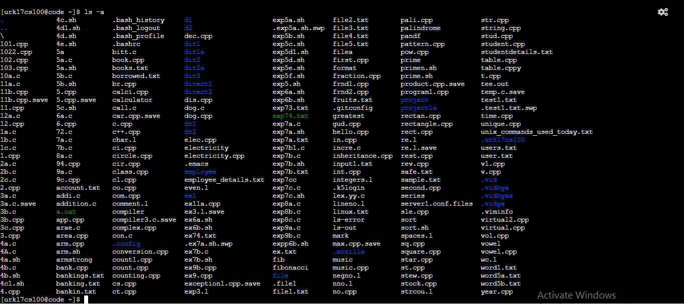

**2. List the content of /var directory?**

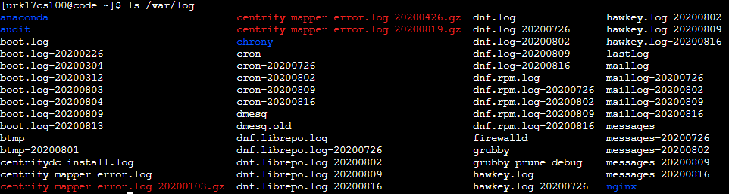

**3. Create two directories named dir1 & dir2**

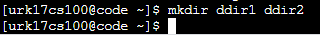

**4. Create a hidden directory with your name?**

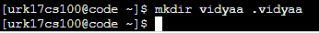

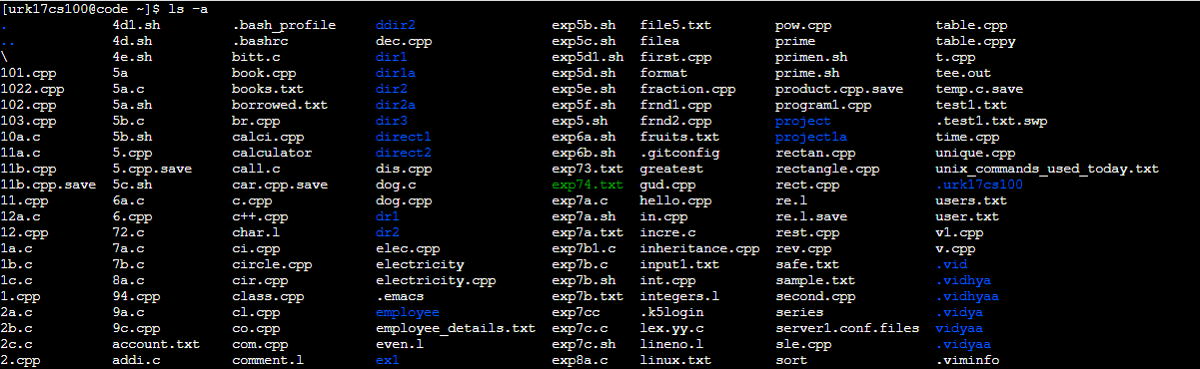

**5. Display the content of a hidden directory.**

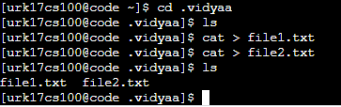

**6. Display the calendar of 2020.**

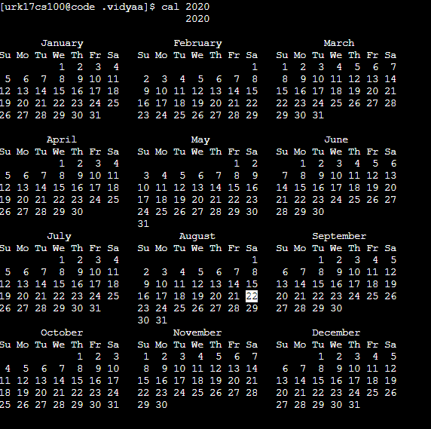

**7. Copy the file /etc/passwd file to current directory with sample.txt as the filename**

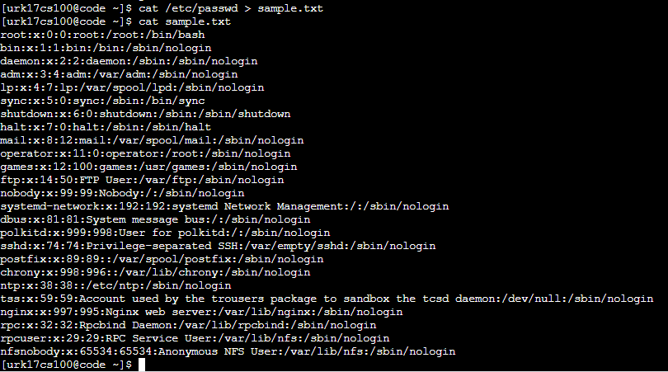

**8. Create a file test1.txt using Vim editor with the following contents to it**

**Name RegNo ResearchInterest**

Melvin 07af501 GridComputing

Mithin 07af502 ClusterComputing

James 07af503 ImageProcessing

Jane 07af504 Networking

Caroline 07af505 ClusterComputing

Binu 07af506 GridComputing

Aaron 07af507 ImageProcessing

Selvin 07af508 Networking

Jerwin 07af509 WirelessNetworks

Arun 07af510 GridComputing

**Answer the following questions**

**a) Display the student names who are having Research Interest as GridComputing**

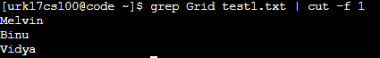

**b) List all the student names & RegNo in the class**

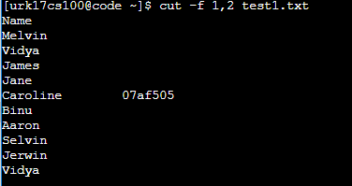

**c) List the count of students who have an interest as ImageProcessing and store the result in another file.**

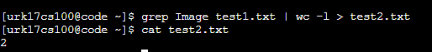

**d) Display the first two rows and last two and store them into another file.**

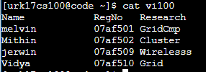

**9. Display the contents of the file test1.txt without any blank lines**

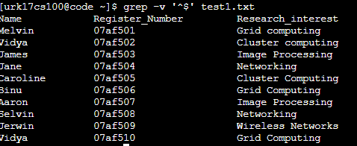

**10. Move the file sample.txt from dir1 directory to dir2 directory**

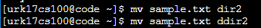

**11. Change directory into dir2 directory**

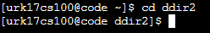

**12. Check whether the file sample.txt is present their**

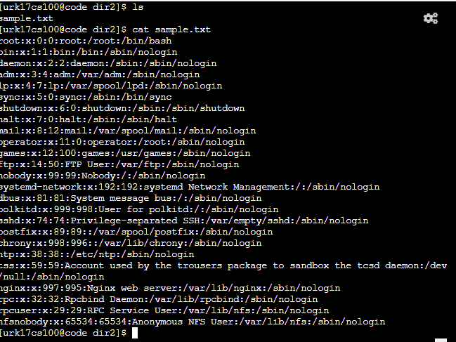

**13. Rename the file sample.txt to new.txt and check whether sample.txt is there or not?**

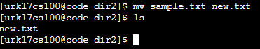

**14. Remove the directory dir1**

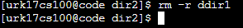

**15. Display last 3 lines of the file test1.txt**

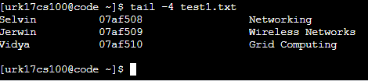

**16. Display all the commands you have executed so far and save the list into a file named todayshistory.txt**

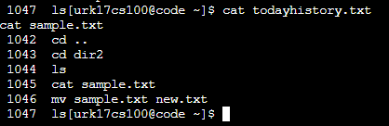

**17. How many files are present under your home directory?**

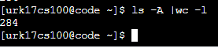

**18. Perform the sorting of three files and store the sorted file in the fourth file.**

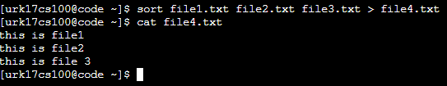

**19. Change the permission of your newly created file such that the group users and others don’t access any type of access.**

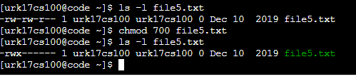

**20. Display the network status on the shell.**

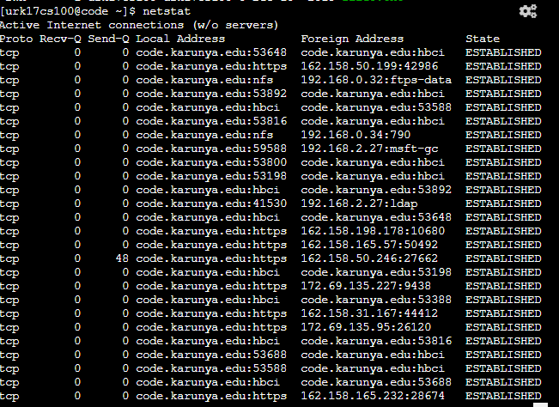

**21. Compares any two files and search for both common and exclusive features**

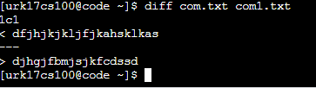

**22. Display the user ID, process ID, and parent process ID.**

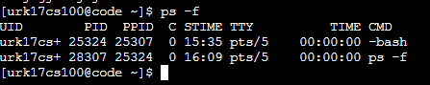

**23. Report disk usages of the file system.**

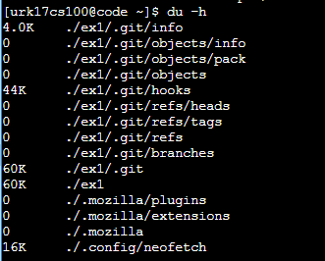

**24. Display the statistics of all ports connected to a network.**

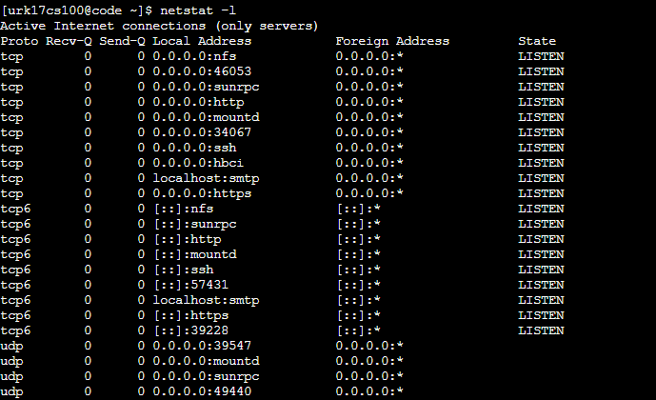

**25. Display the uptime of the system.**



**26. Julian day.**

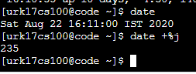

**27. IP information.**

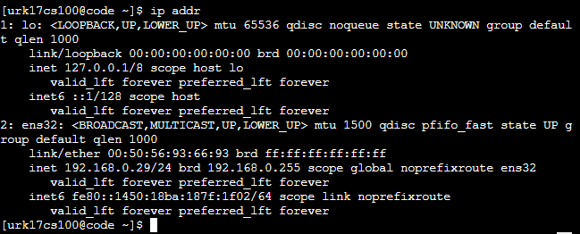

**28. Display only the free space in the system.**

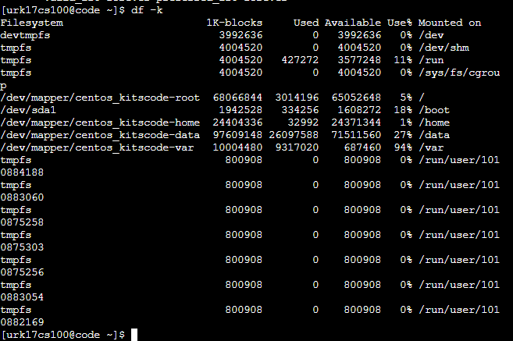

**29. Linux platform is infected over the network.**

**30. Display the configuration information of your network.**

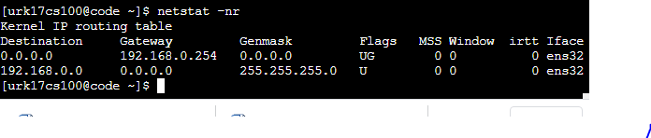

**Results:**

The Linux commands are studied and executed.

**Video Link:**

<http://www.youtube.com/watch?v=0pNflbBLeSY>

**Ex 2 KERNEL CONFIGURATION, COMPILATION AND INSTALLATION**

**Date: 25.08.20**

**Aim:**

To study and implement the kernel configuration, compilation and installation.

**Description:**

**The Linux Kernel :**

The main purpose of a computer is to run a predefined sequence of instructions, known as a program. A program under execution is often referred to as a process. Now, most special purpose computers are meant to run a single process, but in a sophisticated system such a general purpose computer, are intended to run many processes simultaneously. Any kind of process requires hardware resources such are Memory, Processor time, Storage space, etc.

In a General Purpose Computer running many processes simultaneously, we need a middle layer to manage the distribution of the hardware resources of the computer efficiently and fairly among all the various processes running on the computer. This middle layer is referred to as the kernel. Basically the kernel virtualizes the common hardware resources of the computer to provide each process with its own virtual resources. This makes the process seem as it is the sole process running on the machine. The kernel is also responsible for preventing and mitigating conflicts between different processes.

The Core Subsystems of the Linux Kernel are as follows:

1. The Process Scheduler
2. The Memory Management Unit (MMU)
3. The Virtual File System (VFS)
4. The Networking Unit
5. Inter-Process Communication Unit

This schematically represented below:

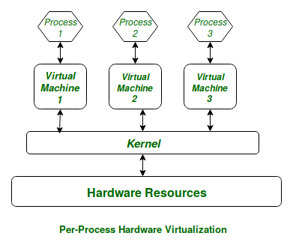

**Architecture of system kernel :**

We can think of Linux Kernel architecture to be divided into two levels – User Space and Kernel Space.

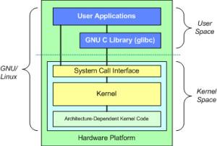

At the top is the user space. Below the user space is the kernel space. Here, the Linux kernel exists.

User Space:

This is where the user applications are executed. There is also the GNU C Library (glibc). This provides the system call interface that connects to the kernel and provides the mechanism to transition between the user-space application and the kernel.

Kernel Space:

Here, the Linux Kernel exists which can be further divided into three levels. At the top is the system call interface, which implements the basic functions such as read and write. Below the system call interface is the kernel code, which can be more accurately defined as the architecture-independent kernel code. This code is common to all of the processor architectures supported by Linux. Below this is the architecture-dependent code, which forms what is more commonly called a BSP (Board Support Package). This code serves as the processor and platform-specific code for the given architecture.

|  |  |  |  |
| --- | --- | --- | --- |
| Sl. No. | Command Name | Meaning | Description |
| 1. | rpm -qa kernel-devel | It displays the version of the kernel. | Kernel-devel - This package provides kernel headers and makes files sufficient to build modules against the kernel package. |
| 2. | uname –r | uname displays the information about the system. | The command ‘uname‘ displays the information about the system.  option :  **-a** It prints all the system information in the following order: Kernel name, network node hostname, kernel release date, kernel version, machine hardware name, hardware platform, operating system  **-s** It prints the kernel name.  **-n** It prints the hostname of the network node  **-r** It prints the kernel release date  **-v** It prints the version of the current kernel |
| 3. | tar | tar’ stands for tape archive, is used to create Archive and extract the Archive files | tar command in Linux is one of the important commands which provides archiving functionality in Linux. We can use Linux tar command to create compressed or uncompressed Archive files and also maintain and modify them.  **Options:**  **-c :** Creates Archive  **-x :** Extract the archive  **-f :** creates archive with given filename  **-t :** displays or lists files in archive file  **-u :** archives and adds to an existing archive file  **-v :** Displays Verbose Information  **-A :** Concatenates the archive files  **-z :** zip, tells tar command that create tar file using gzip  **-j :** filter archive tar file using tbzip  **-W :** Verify a archive file  **-r :** update or add file or directory in already existed .tar file |
| 4. | ln | A symbolic link, also known as a symlink or soft link, is a special type of file that points to another file or directory. | There are two types of links in Linux/UNIX systems:   1. Hard links 2. Soft links |
| 5. | make | utility for building and maintaining groups of programs. | The purpose of the make utility is to determine automatically which pieces of a large program need to be recompiled, and issue the commands to recompile them. you can use make with any programming language whose compiler can be run with a shell command. In fact, make is not limited to programs. You can use it to describe any task where some files must be updated automatically from others whenever the others change. Options :  **-b,-m** prints online help and exitThese options are ignored for compatibility with other versions of make.  **-B** Unconditionally make all targets  **-d** Print debugging information in addition to normal processing  **-e** Give variables taken from the environment precedence over variables from makefiles  **-k** Continue as much as possible after an error |

**Exercise**

**Configure and compilation the kernel**

**Step 1 :**

Download the latest kernel source from www.kernel.org or from a repository.

**Step 2 :**

Check the current kernel version and name of the kernel.

**step 3 :**

Move the module from downloads to /usr/src and uzip the file.

**step 4 :**

Make a systemlink to the existing kernel and clean the existing kernel.

**step 5 :**

Building kernel and its modules.

**step 6 :**

Check the current kernel version and name of the kernel.

**Output :**

Kernel Version



Kernel Name

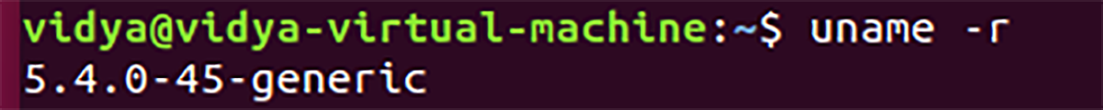

Unzipping kernel file





Moving the kernel to /usr/src

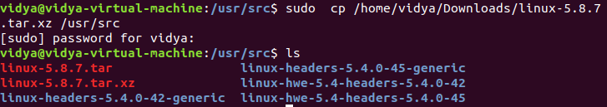

Cleaning the kernel using make



System link to existing kernel



Making target files



Installing Kernel config

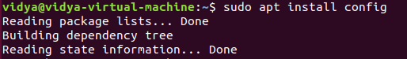

**Results:**

The study and implement the kernel configuration, compilation and installation is studied and executed.

**Video :**

<http://www.youtube.com/watch?v=UQWl5LMU11c>

**Ex 3 COMPILING FROM THE SOURCE**

**Date: 29.08.20**

**Aim:**

To study and implement the compiling from the source.

**Description:**

**tar Command :**

The Linux ‘tar’ stands for tape archive, is used to create Archive and extract the Archive files. tar command in Linux is one of the important commands which provides archiving functionality in Linux. We can use Linux tar command to create compressed or uncompressed Archive files and also maintain and modify them.

**Syntax :**

tar [options] [archive-file] [file or directory to be archived]

Options:

**-c :** Creates Archive

**-x :** Extract the archive

**-f :** creates archive with given filename

**-t :** displays or lists files in archive file

**-u :** archives and adds to an existing archive file

**-v :** Displays Verbose Information

**-A :** Concatenates the archive files

**-z :** zip, tells tar command that create tar file using gzip

**-j :** filter archive tar file using tbzip

**-W :** Verify a archive file

**-r :** update or add file or directory in already existed .tar file

# zip Command :

ZIP is a compression and file packaging utility for Unix. Each file is stored in a single .zip {.zip-filename} file with the extension .zip.

* zip is used to compress the files to reduce file size and also used as file package utility. zip is available in many operating systems like unix, linux, windows etc.
* If you have a limited bandwidth between two servers and want to transfer the files faster, then zip the files and transfer.
* The zip program puts one or more compressed files into a single zip archive, along with information about the files (name, path, date, time of last modification, protection, and check information to verify file integrity). An entire directory structure can be packed into a zip archive with a single command.
* Compression ratios of 2:1 to 3:1 are common for text files. zip has one compression method (deflation) and can also store files without compression. zip automatically chooses the better of the two for each file to be compressed.  
   The program is useful for packaging a set of files for distribution; for archiving files; and for saving disk space by temporarily compressing unused files or directories.

**Syntax :**

zip [options] zipfile files_list

**Syntax for** **Creating a zip file:**

$zip myfile.zip filename.txt

Options :

**-d** : Removes the file from the zip archive

**-u** : Updates the file in the zip archive

**-m** : Deletes the original files after zipping

**-r** : To zip a directory recursively

**-x** : Exclude the files in creating the zip

**-v** : Verbose mode or print diagnostic version info

# gzip Command :

gzip command compresses files. Each single file is compressed into a single file. The compressed file consists of a GNU zip header and deflated data.

If given a file as an argument, gzip compresses the file, adds a “.gz” suffix, and deletes the original file. With no arguments, gzip compresses the standard input and writes the compressed file to standard output.

**Difference between Gzip and zip command in Unix and when to use which command**

* ZIP and GZIP are two very popular methods of compressing files, in order to save space, or to reduce the amount of time needed to transmit the files across the network, or internet.
* In general, GZIP is much better compared to ZIP, in terms of compression, especially when compressing a huge number of files.
* The common practice with GZIP, is to archive all the files into a single tarball before compression. In ZIP files, the individual files are compressed and then added to the archive.
* When you want to pull a single file from a ZIP, it is simply extracted, then decompressed. With GZIP, the whole file needs to be decompressed before you can extract the file you want from the archive.
* When pulling a 1MB file from a 10GB archive, it is quite clear that it would take a lot longer in GZIP, than in ZIP.
* GZIP’s disadvantage in how it operates, is also responsible for GZIP’s advantage. Since the compression algorithm in GZIP compresses one large file instead of multiple smaller ones, it can take advantage of the redundancy in the files to reduce the file size even further.
* If you archive and compress 10 identical files with ZIP and GZIP, the ZIP file would be over 10 times bigger than the resulting GZIP file.

**Syntax :**

gzip [Options] [filenames]

Options:

**-f** : Sometimes a file cannot be compressed

**-k** : By default when you compress a file using the “gzip” command you end up with a new file with the extension

**-L** : This option displays the gzip license

**-r** : This option can compress every file in a folder and its subfolders

**-[1-9]** : It allows to change the compression level

**-v** : his option displays the name and percentage reduction for each file compressed or decompressed

**-d** : This option allows you to decompress a file using the “gzip” command.

**Exercise**

**1. Compile the source from openttd package**

Installing openttd using dep(Debian) package

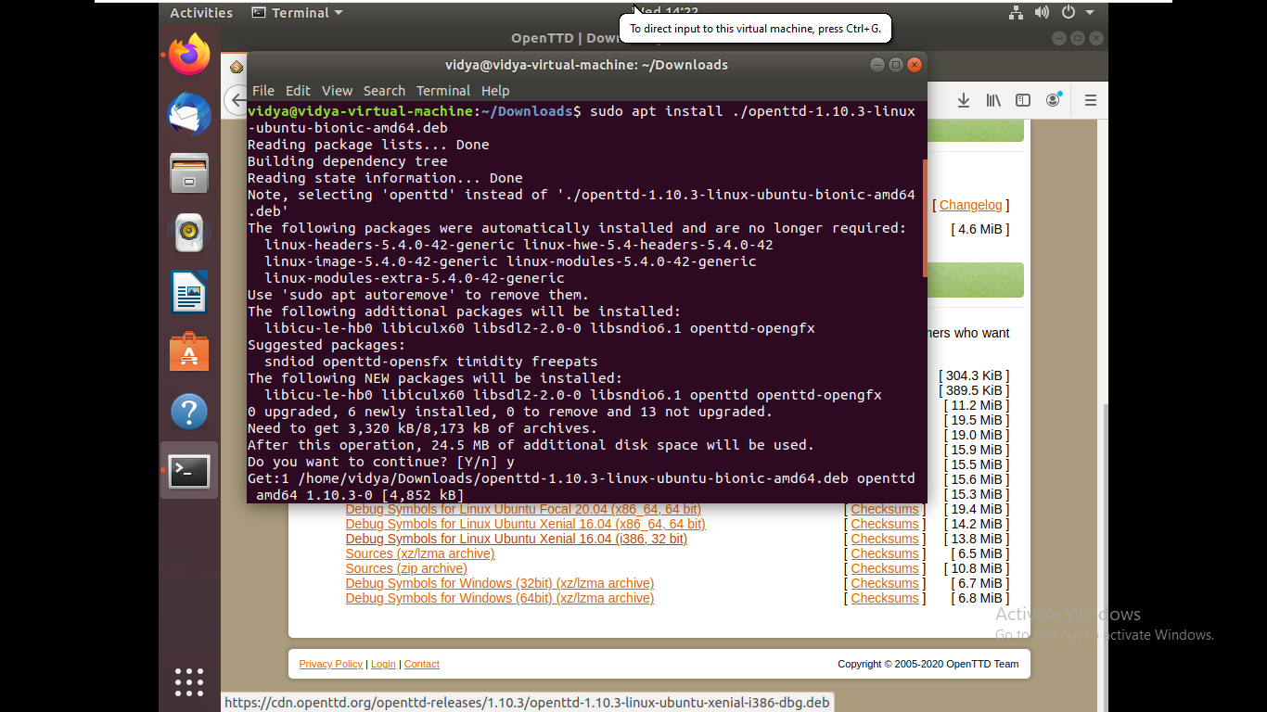

Compiling the source of openttd

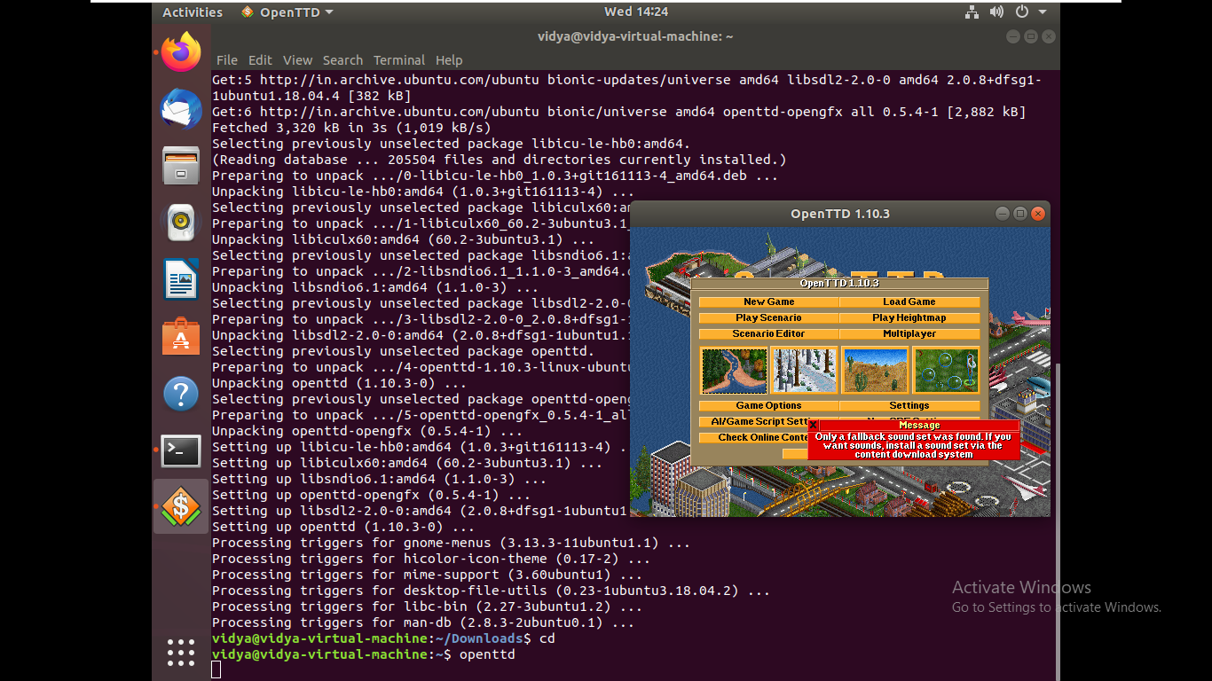

**2. Compile the source from JFrog package**

Installing conan c++ package using dep(Debian) package

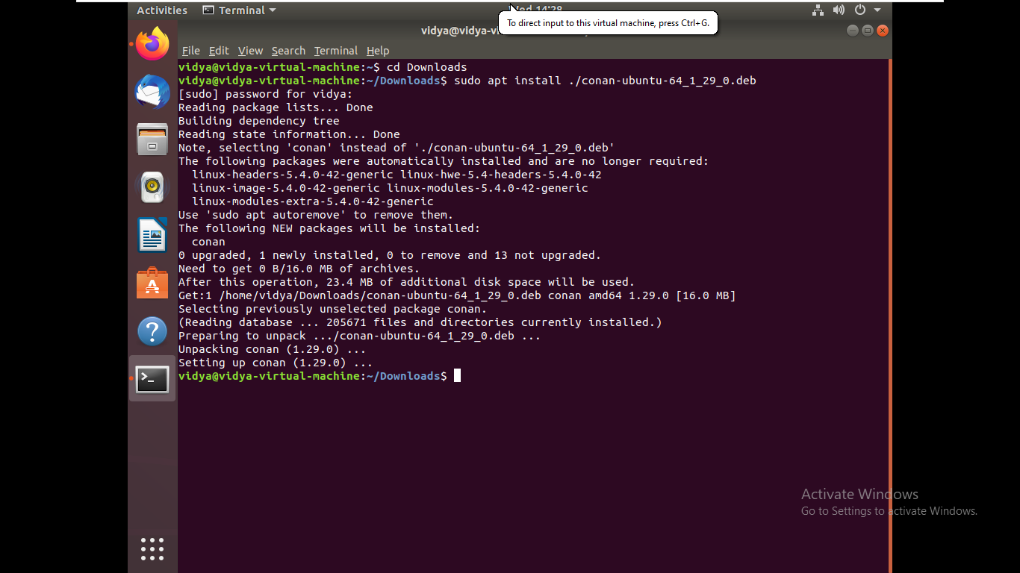

creating a sample package

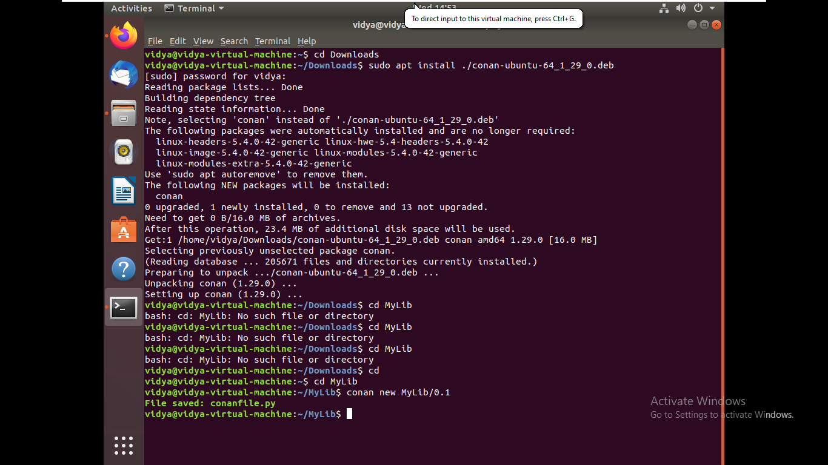

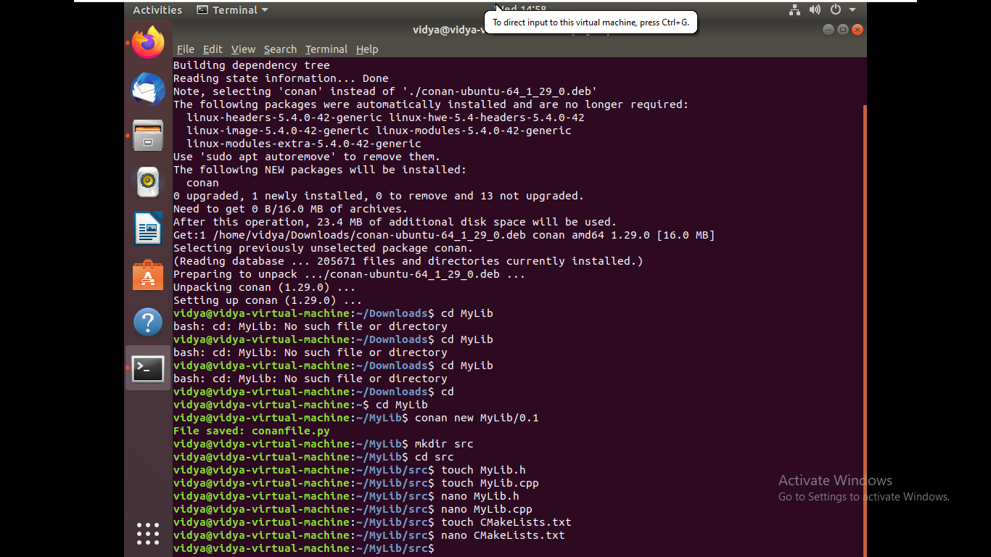

Making up the package

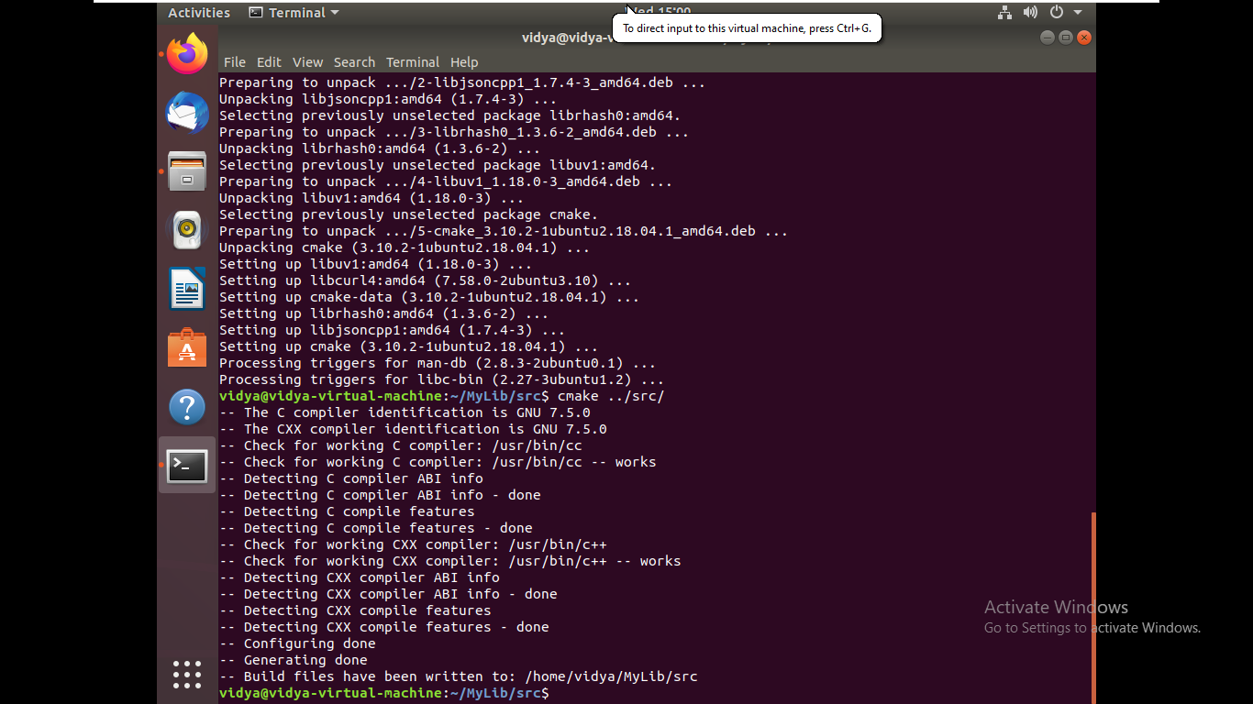

Build package output

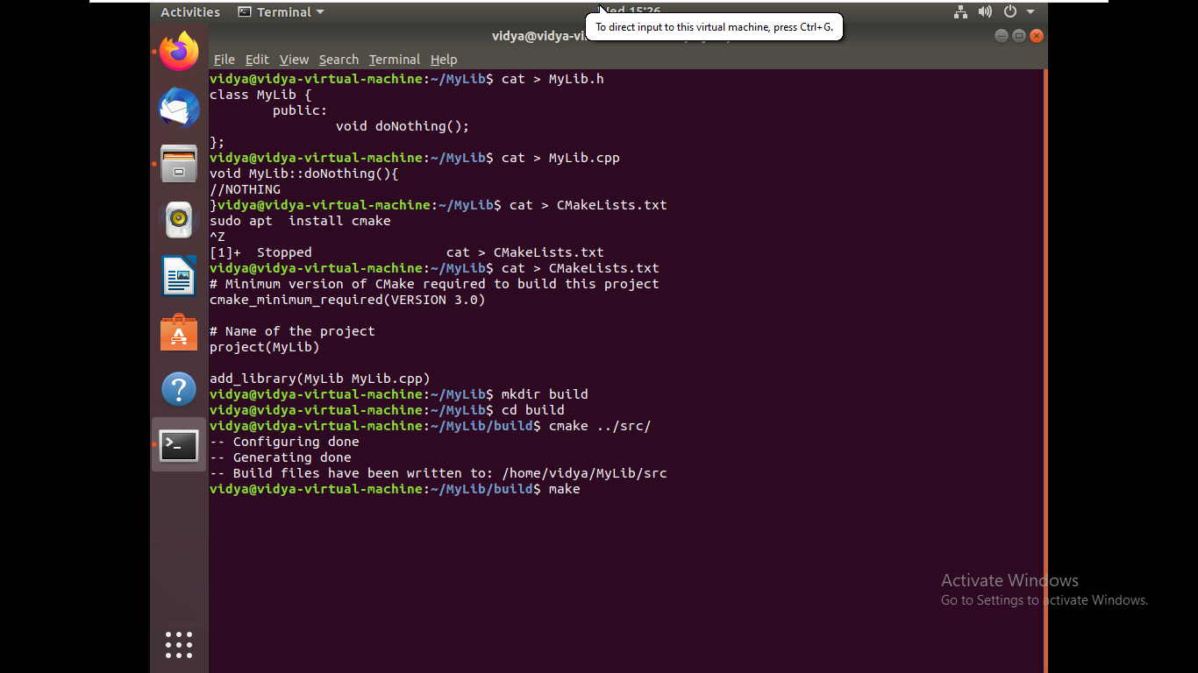

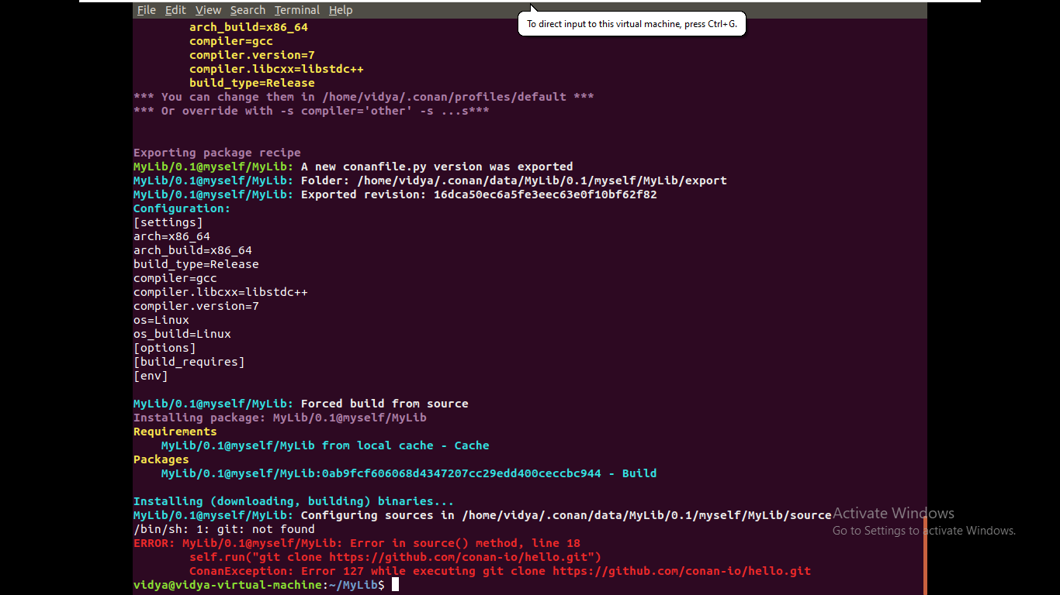

**3. Compile the source from gcc**

Checking the version of gcc

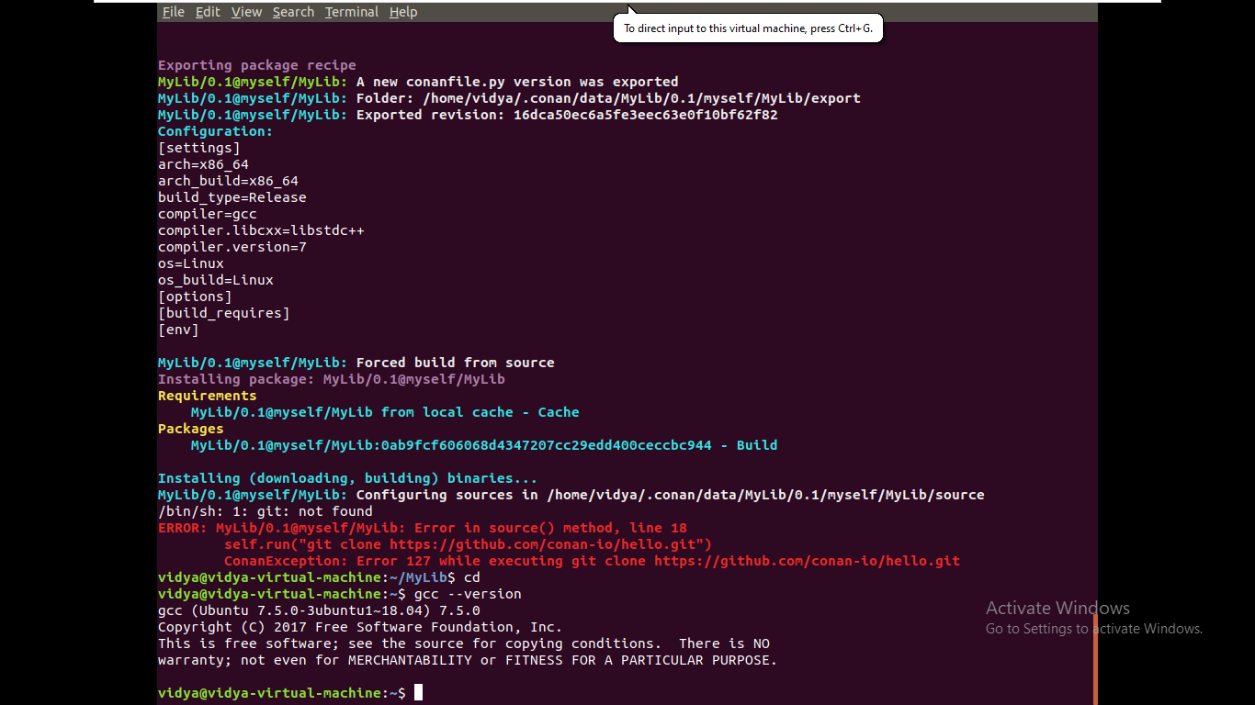

**Program :**

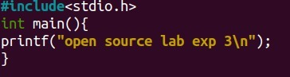

**Output :**

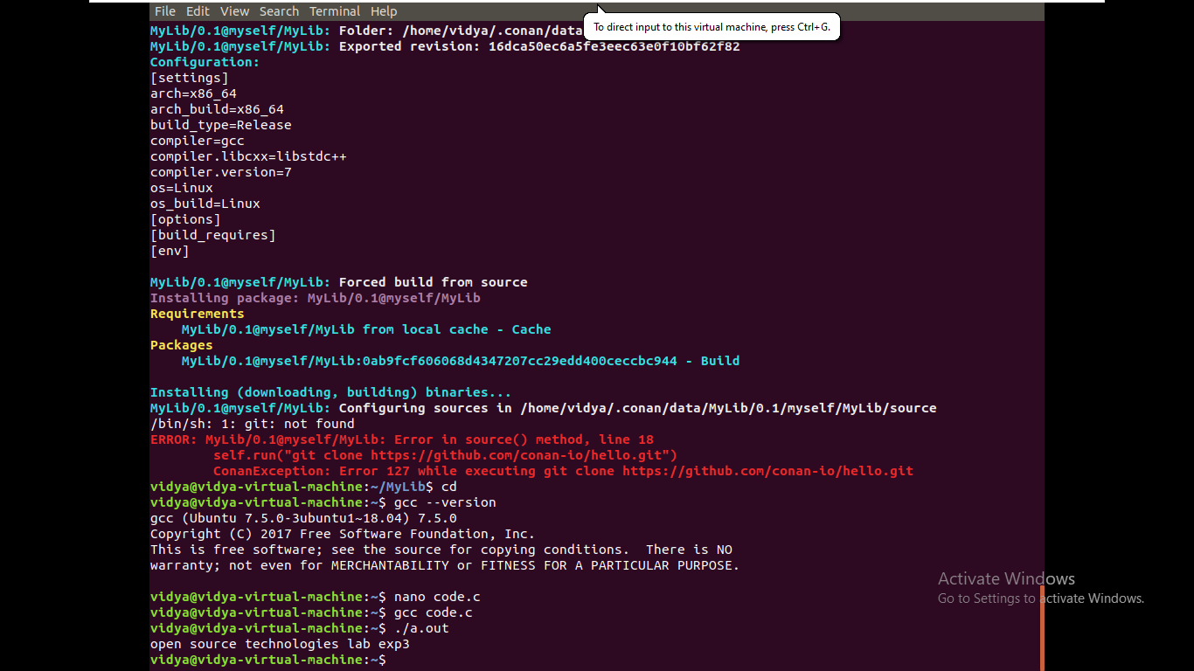

**4. Compile the source from any open source package**

Installing ganache(open source package) using AppImage

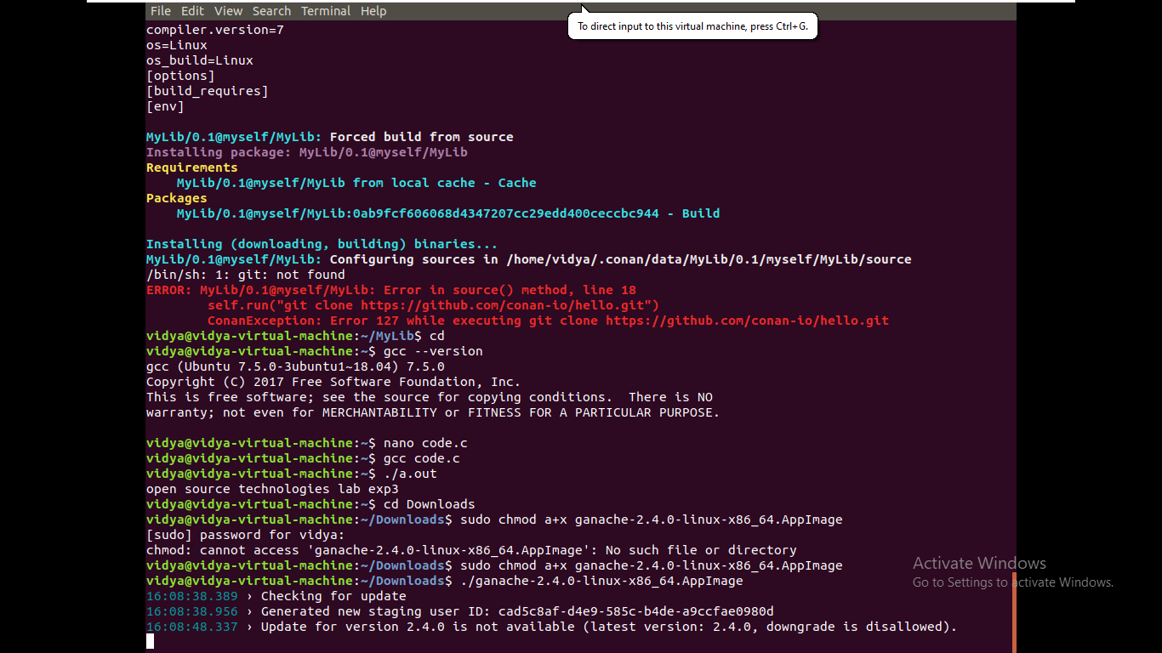

Compiling an open source package

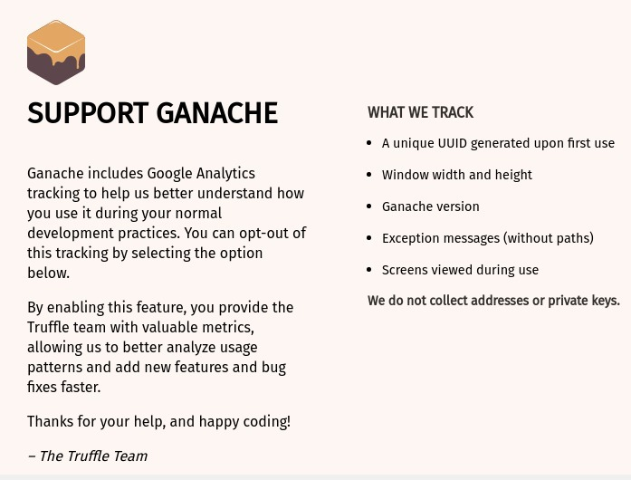

**Results:**

The compiling from the source is studied and executed.

**Video :**

<http://www.youtube.com/watch?v=pnJgAH2E4mk>

**Ex 4 Virtualization**

**Date: 01.09.2020**

**Aim:**

To study and implement the installation of FreeDOS and overlay the emulator.

1. Install FreeDOS and overlay the QEMU emulator over the OS

2. Any emulator: open-source application over FreeDOS

**Description:**

**FreeDOS :**

DOS is a "disk operating system" created when personal computers ran from floppy disks. Even when computers supported hard drives, it was common in the 1980s and 1990s to switch frequently between the different drives. For example, you might make a backup copy of your most important files to a floppy disk.

FreeDOS is an old operating system, but it is new to many people. In 1994, several developers and I came together to create FreeDOS—a complete, free, DOS-compatible operating system you can use to play classic DOS games, run legacy business software, or develop embedded systems. Any program that works on MS-DOS should also run on FreeDOS.

**QEMU:**

QEMU is a generic and open source machine & userspace emulator and virtualizer.

What QEMU can do:

Emulate a complete machine without hardware virtualization

Emulate with Xen/KVM hypervisors

Provide userspace API virtualization

In computing, an emulator is a hardware or software that enables one computer system (called the host) to behave like another computer system (called the guest).

In 1963, when microcode was first used to speed up this simulation process, IBM engineers coined the term “emulator” to describe the concept. In the 2000s, it has become common to use the word “emulate” in the context of software. However, before 1980, “emulation” referred only to emulation with a hardware or microcode assist, while “simulation” referred to pure software emulation.

Purists continue to insist on this distinction, but currently, the term “emulation” often means the complete imitation of a machine executing binary code while “simulation” often refers to computer simulation, where a computer program is used to simulate an abstract model.

**VirtualBox:**

VirtualBox is a powerful x86 and AMD64/Intel64 virtualization product for enterprise as well as home use. Not only is VirtualBox an extremely feature-rich, high-performance product for enterprise customers, it is also the only professional solution that is freely available as Open Source Software under the terms of the GNU General Public License (GPL) version 2.

Presently, VirtualBox runs on Windows, Linux, Macintosh, and Solaris hosts and supports a large number of guest operating systems including but not limited to Windows (NT 4.0, 2000, XP, Server 2003, Vista, Windows 7, Windows 8, Windows 10), DOS/Windows 3.x, Linux (2.4, 2.6, 3.x and 4.x), Solaris and OpenSolaris, OS/2, and OpenBSD.

VirtualBox is being actively developed with frequent releases and has an ever-growing list of features, supported guest operating systems, and platforms it runs on. VirtualBox is a community effort backed by a dedicated company: everyone is encouraged to contribute while Oracle ensures the product always meets professional quality criteria.

**Exercise**

**1. Install FreeDOS and overlay the QEMU emulator over the OS**

**Step 1 :**

Installing Qemu

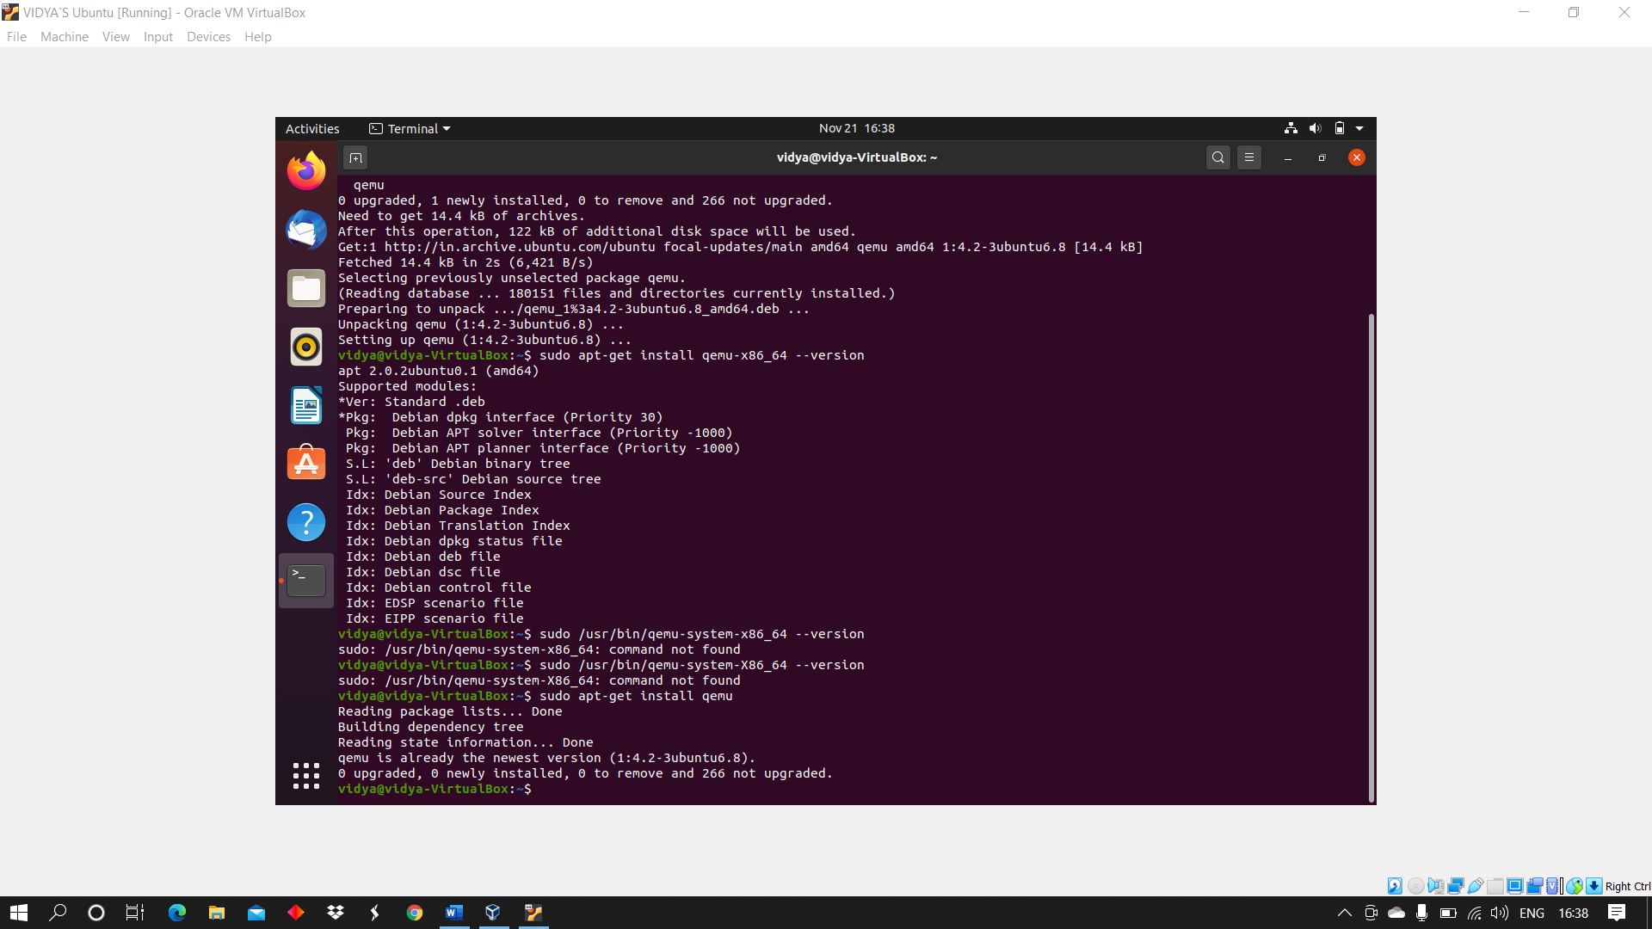

**Step 2 :**

Check version

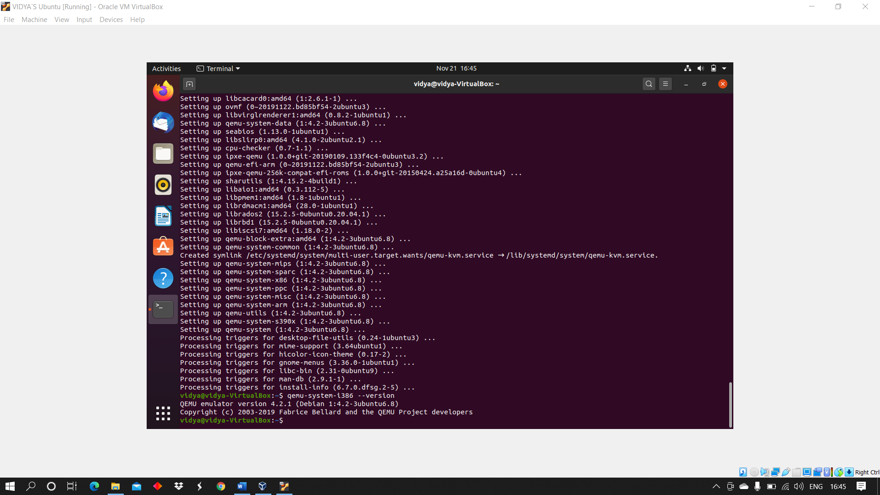

**Step 3 :**

Adding files and checking the status & move the downloaded file of FreeDOS for installing FreeDOS

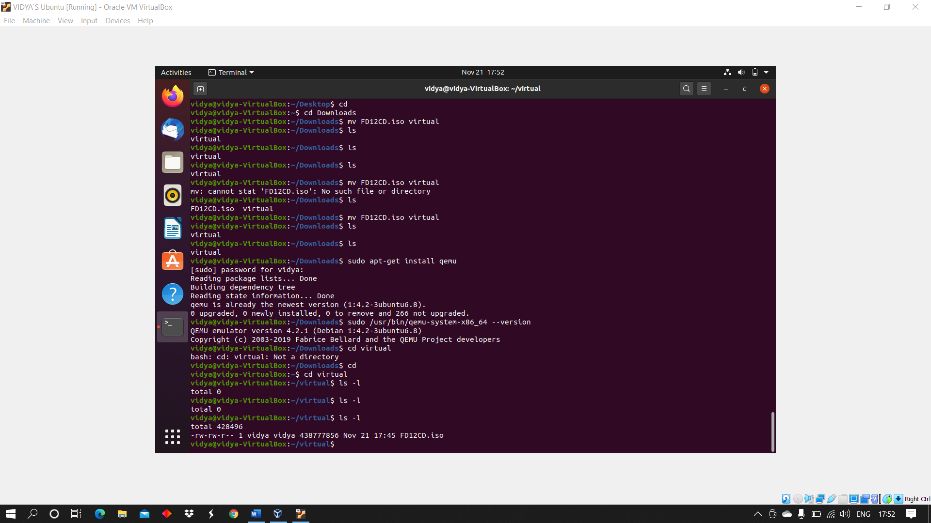

**Step 4 :**

Create a virtual disk space of 200MB for installing free dos

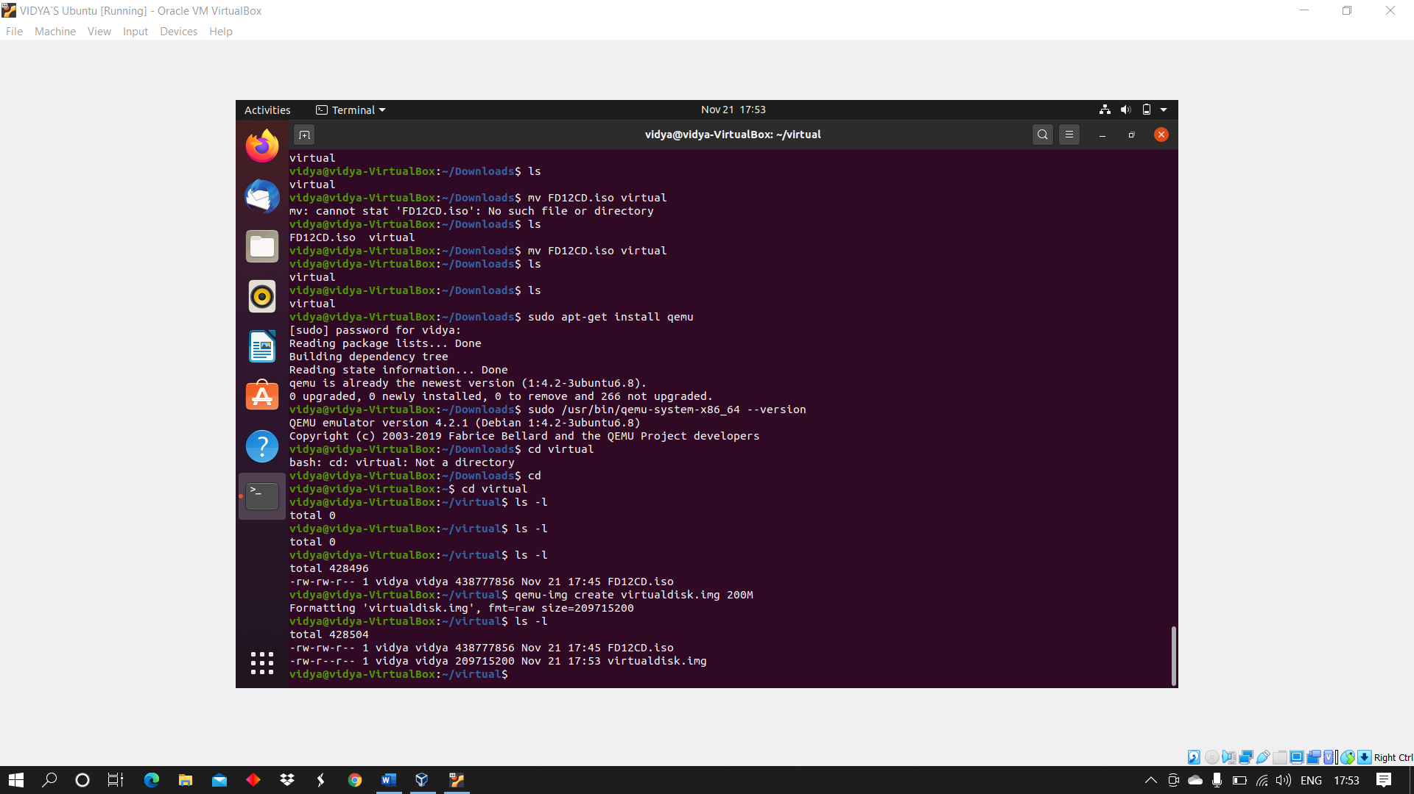

**Step 5 :**

Boot the iso file from CDrom for installing

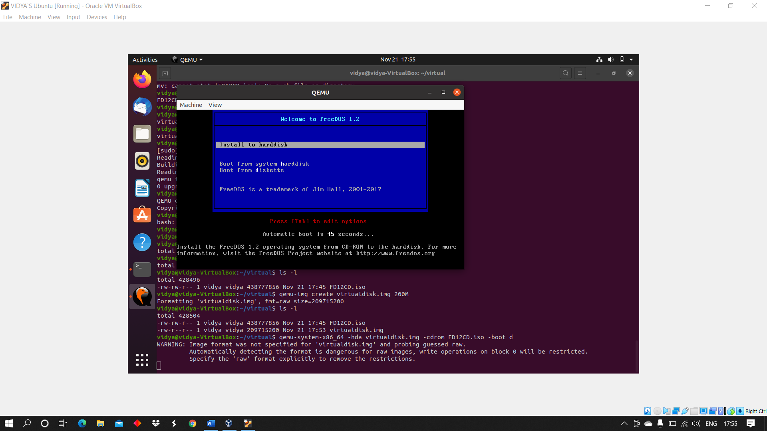

**2. Install any emulator: open-source application over FreeDOS**

**Step 1 :**

Installing VirtualBox & version

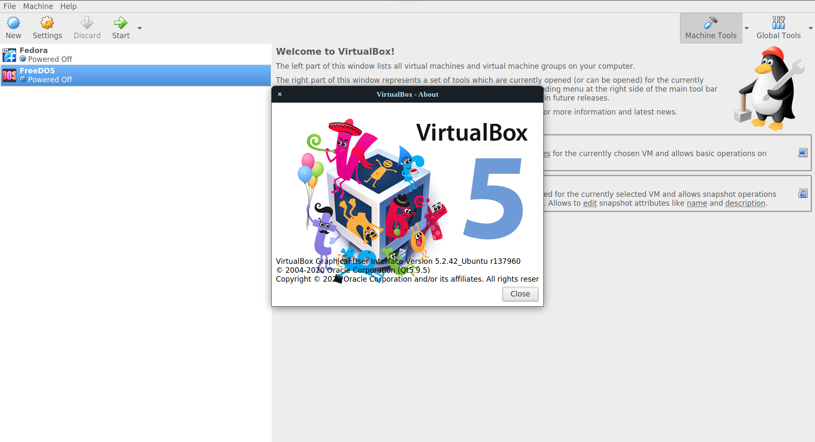

**Step 2 :**

Create a virtual machine, name it as FreeDOS, and select a memory size of 4MB

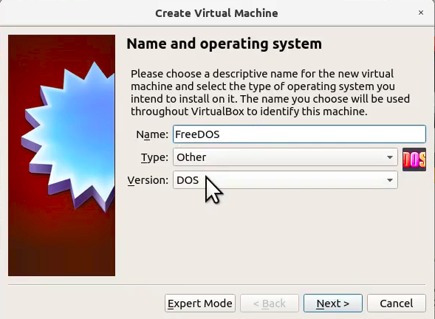

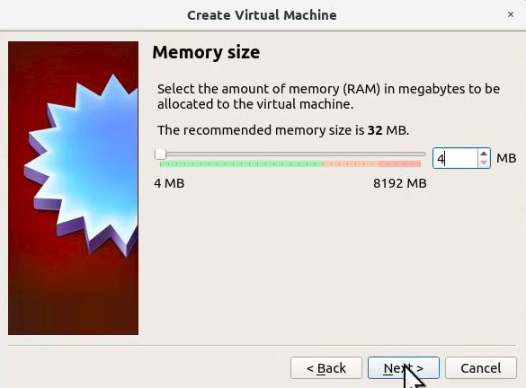

**Step 3 :**

Start your virtual machine, press the tab key to enter the command as raw, select the preferred language and reboot the machine

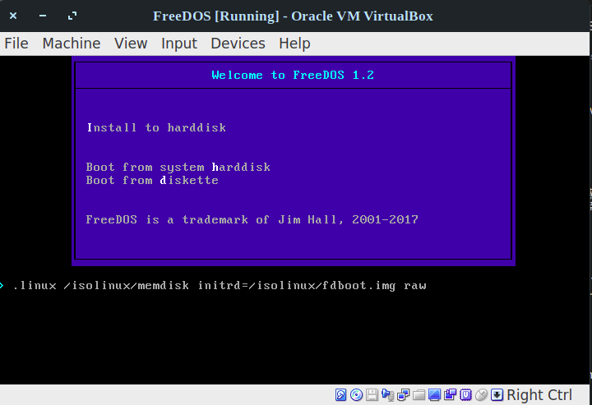

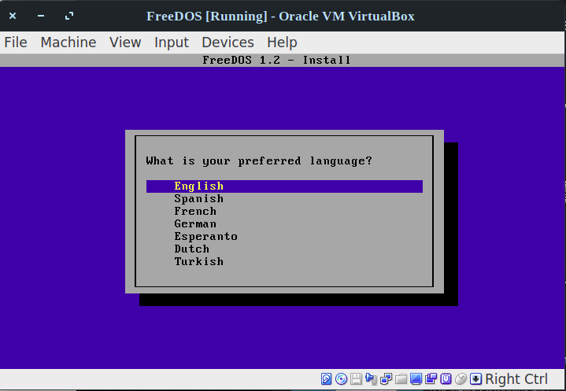

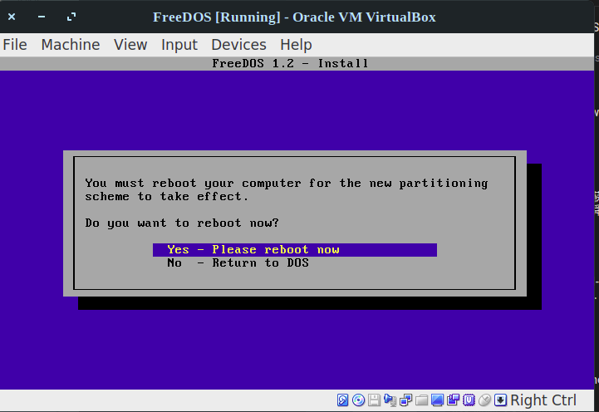

**Step 4 :**

Erase the C: and format to appear C, Press Full installation and reboot the machine

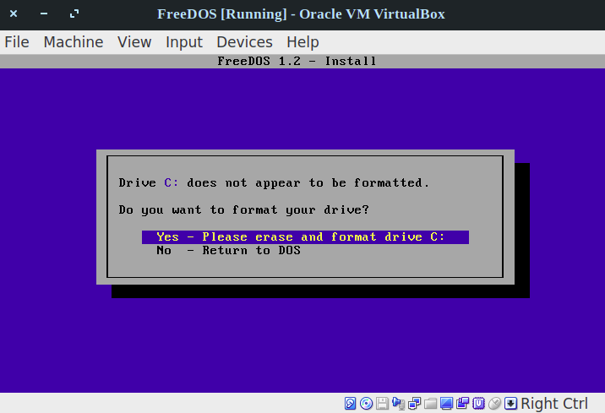

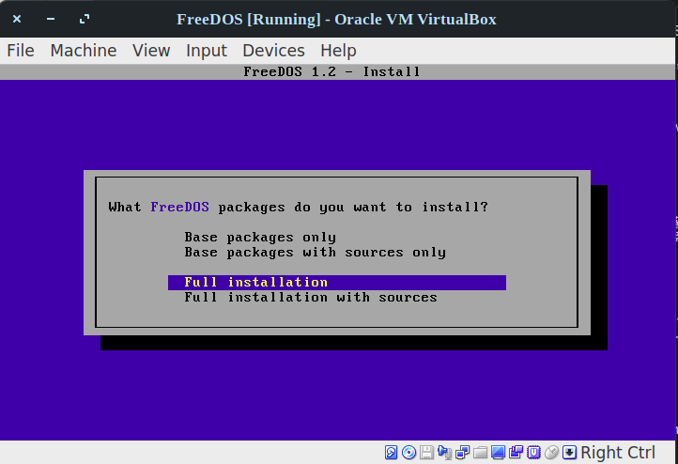

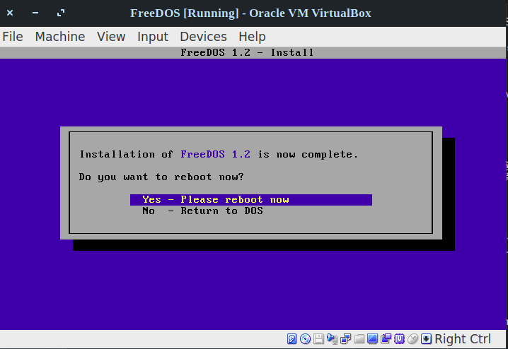

**Step 5 :**

Your FreeDOS is ready to use

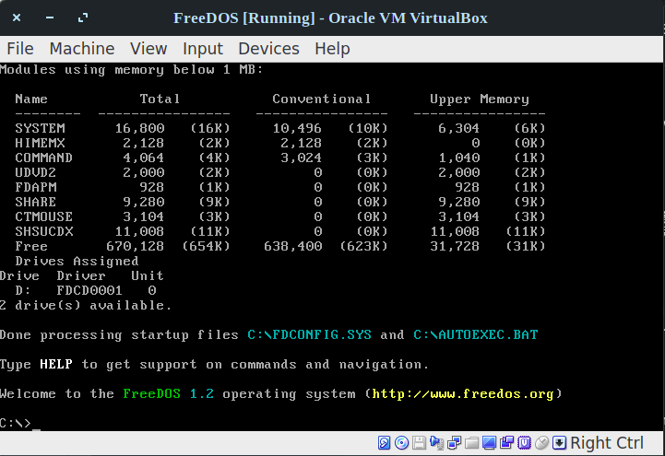

**Results:**

The study and implementation of the installation of FreeDOS and overlay of the emulator are studied and executed.

**Video link :** [**http://www.youtube.com/watch?v=BnBZ2RSzlK8**](http://www.youtube.com/watch?v=BnBZ2RSzlK8)

**Ex 5 Package Management System**

**Date: 29.08.20**

**Aim:**

To study and implement the package management system

**Description:**

**Samba :**

Samba is a free and open-source re-implementation of the SMB/CIFS network file sharing protocol that allows end users to access files, printers, and other shared resources.

This tutorial explains how to install Samba on Ubuntu 20.04 and configure it as a standalone server to provide file sharing across different operating systems over a network.

We’ll create the following Samba shares and users.

Users:

* **sadmin** - An administrative user with read and write access to all shares.
* **josh** - A regular user with its own private file share

Shares:

* **users** - This share will be accessible with read/write permissions by all users.
* **josh** - This share will be accessible with read/write permissions only by users josh and sadmin.

The file shares will be accessible from all devices on your network. Later in this tutorial, we will also provide detailed instructions on how to connect to the Samba server from Linux, Windows and macOS clients.

**Exercise**

**1. Install (Samba) free software re-implementation of the SMB/CIFS networking protocol.**

Installing samba using terminal

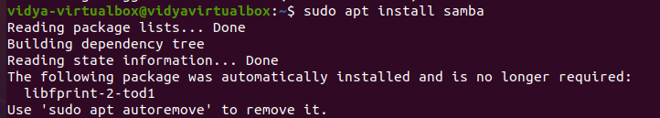

Checking the status of Samba service

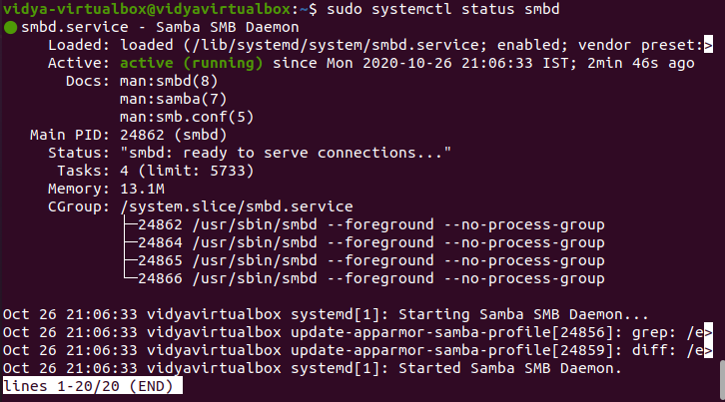

Starting Samba using start smbd

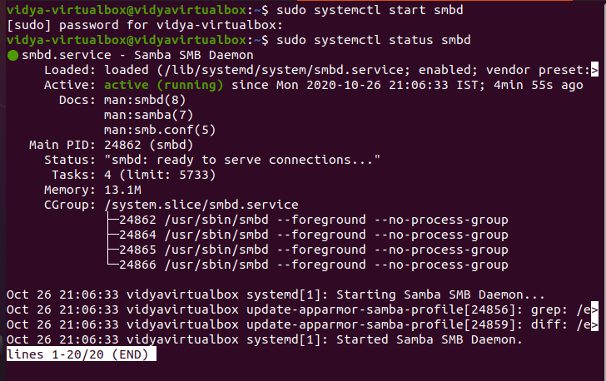

Restart Samba using restart smbd

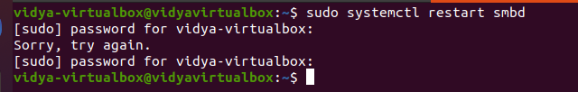

Allow Samba service from firewall

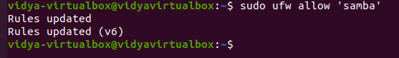

Enforce Permissive State

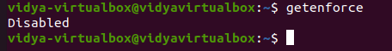

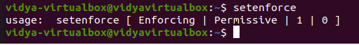

Creating a normal user named Josh and setting up the Password

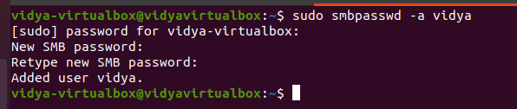

Installing smbclient from terminal to access localhost

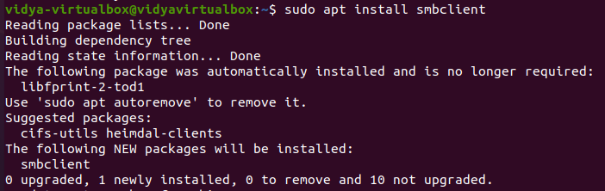

Login into smbclient and listing number of documents



**Results:**

The package management system is studied and executed.

**Video :** [**http://www.youtube.com/watch?v=8a08KQ-_sK0**](http://www.youtube.com/watch?v=8a08KQ-_sK0)

**Ex 6 REPOSITORY IN GITHUB**

**Date: 25.08.20**

**Aim:**

To study and implement the git and git repository.

**Description:**

**The Linux Kernel :**

**GitHub** is a Git repository hosting service, but it adds many of its own features. While Git is a command line tool, **GitHub** provides a Web-based graphical interface. It also provides access control and several collaboration features, such as a wikis and basic task management tools for every project.

**GitHub** is a website for developers and programmers to collaboratively work on code. The primary benefit of **GitHub** is its version control system, which allows for seamless collaboration without compromising the integrity of the original project.

**COMMANDS**:

|  |  |  |
| --- | --- | --- |
| Sl. No. | COMMAND | DESCRIPTION |
| 1. | git init | Initialize git repository |
| 2. | git add filename | To add individual files |
| 3. | git add * | To add all files |
| 4. | git status | To see the added files status |
| 5. | git commit -m “text” | Added text note with added file |
| 6. | git remote add origin path | To link the files to the github repository |
| 7. | git push -u origin master | To push files into the repository |

**Exercise**

**Create repository and uploading files in github**

**Step 1 :**

Installing git

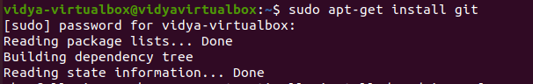

**Step 2 :**

Check version

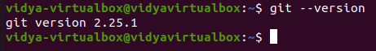

**Step 3 :**

Initializing git

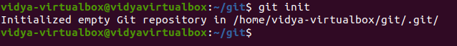

**Step 4 :**

Adding files and checking status

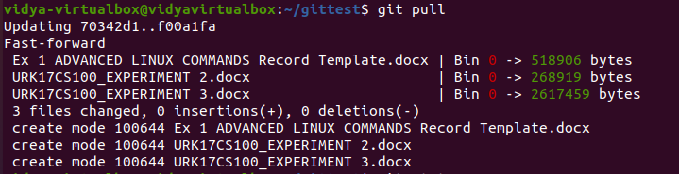

**Step 5 : checking Repository**

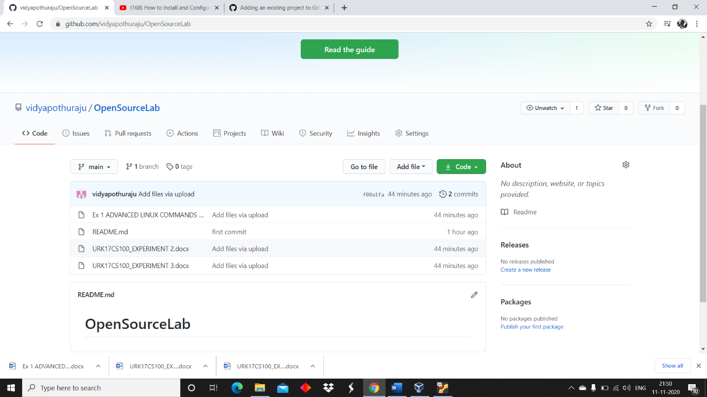**Github link :**

<https://github.com/vidyapothuraju/OpenSourceLab.git>

**Results:**

The study and implementation of the git and git repository is studied and executed.

**Video link :** [**http://www.youtube.com/watch?v=7vdUsCSAq-s**](http://www.youtube.com/watch?v=7vdUsCSAq-s)

**Ex 7 Basic Python Programming**

**Date: 06.10.2020**

**Aim:**

To study and implement the basic python programming.

**Exercise**

**1. Design and implement a basic calculator.**

**Source Code :**

a = int(input("enter the first number :"))

b = int(input("enter the second number :"))

c = int(input("enter the operation you want :\n 1.Add \n 2.Sub \n 3.Mul \n 4.Div \n"))

if c==1:

print(a+b)

elif c==2:

print(a-b)

elif c==3:

print(a*b)

elif c==4:

print(a/b)

else:

print("choose the correct operation _ ")

**Output :**

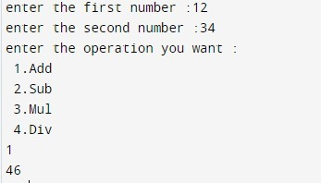

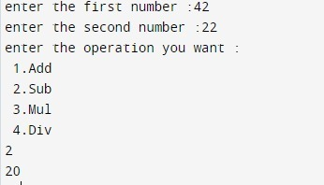

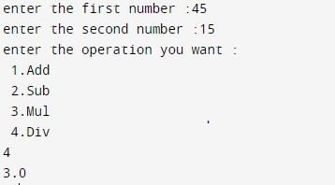

**2. Find whether the given number is perfect or not.**

**Source Code :**

Number = int(input(" Please Enter any Number: "))

Sum = 0

for i in range(1, Number):

if(Number % i == 0):

Sum = Sum + i

if (Sum == Number):

print(" %d is a Perfect Number" %Number)

else:

print(" %d is not a Perfect Number" %Number)

**Output :**

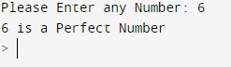

**3. Find whether the given number is Adam’s number or not.**

**Source Code :**

def isAdam(num):

n = num

rev = 0

while n != 0:

rev = rev * 10 + n % 10

n = n // 10

sn = num ** 2

sr = rev ** 2

n = sr

rev = 0

while n != 0:

rev = rev * 10 + n % 10

n = n // 10

return sn == rev

num = int(input("Enter the number: "))

if isAdam(num):

print(str(num) + " is an Adam Number.")

else:

print(str(num) + " is NOT an Adam Number.")

**Output :**

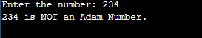

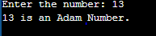

**4. Write a program to check whether the given number is Armstrong or not.**

**Source Code :**

num = int(input("Enter a number: "))

sum = 0

temp = num

while temp > 0:

digit = temp % 10

sum += digit ** 3

temp //= 10

if num == sum:

print(num,"is an Armstrong number")

else:

print(num,"is not an Armstrong number")

**Output :**

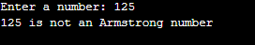



**Results:**

The study and implementation of the basic python programming are studied and executed.

**Video :** [**http://www.youtube.com/watch?v=hXPO3VwUIkc**](http://www.youtube.com/watch?v=hXPO3VwUIkc)

**Ex 8 Basic Perl Programs**

**Date: 06.10.2020**

**Aim:**

To execute basic Perl programs

**Description:**

Perl is a family of two high-level, general-purpose, interpreted, dynamic programming languages. "Perl" refers to Perl 5, but from 2000 to 2019 it also referred to its redesigned "sister language", Perl 6, before the latter's name was officially changed to Raku in October 2019.

A Perl script can be created inside of any normal simple-text editor program. There are several programs available for every type of platform. There are many programs designed for programmers available for download on the web.

Perl uses the backslash (\) character to escape any type of character that might interfere with our code. Let's take one example where we want to print double quote

**QUESTION 1: Perform arithmetic operations using perl**

**PROCEDURE:**

1. Get two number inputs
2. Perform addition operation and display
3. Perform subtraction operation and display
4. Perform multiplication operation and display
5. Perform division operation and display
6. Perform modulus operation and display

**Output:**

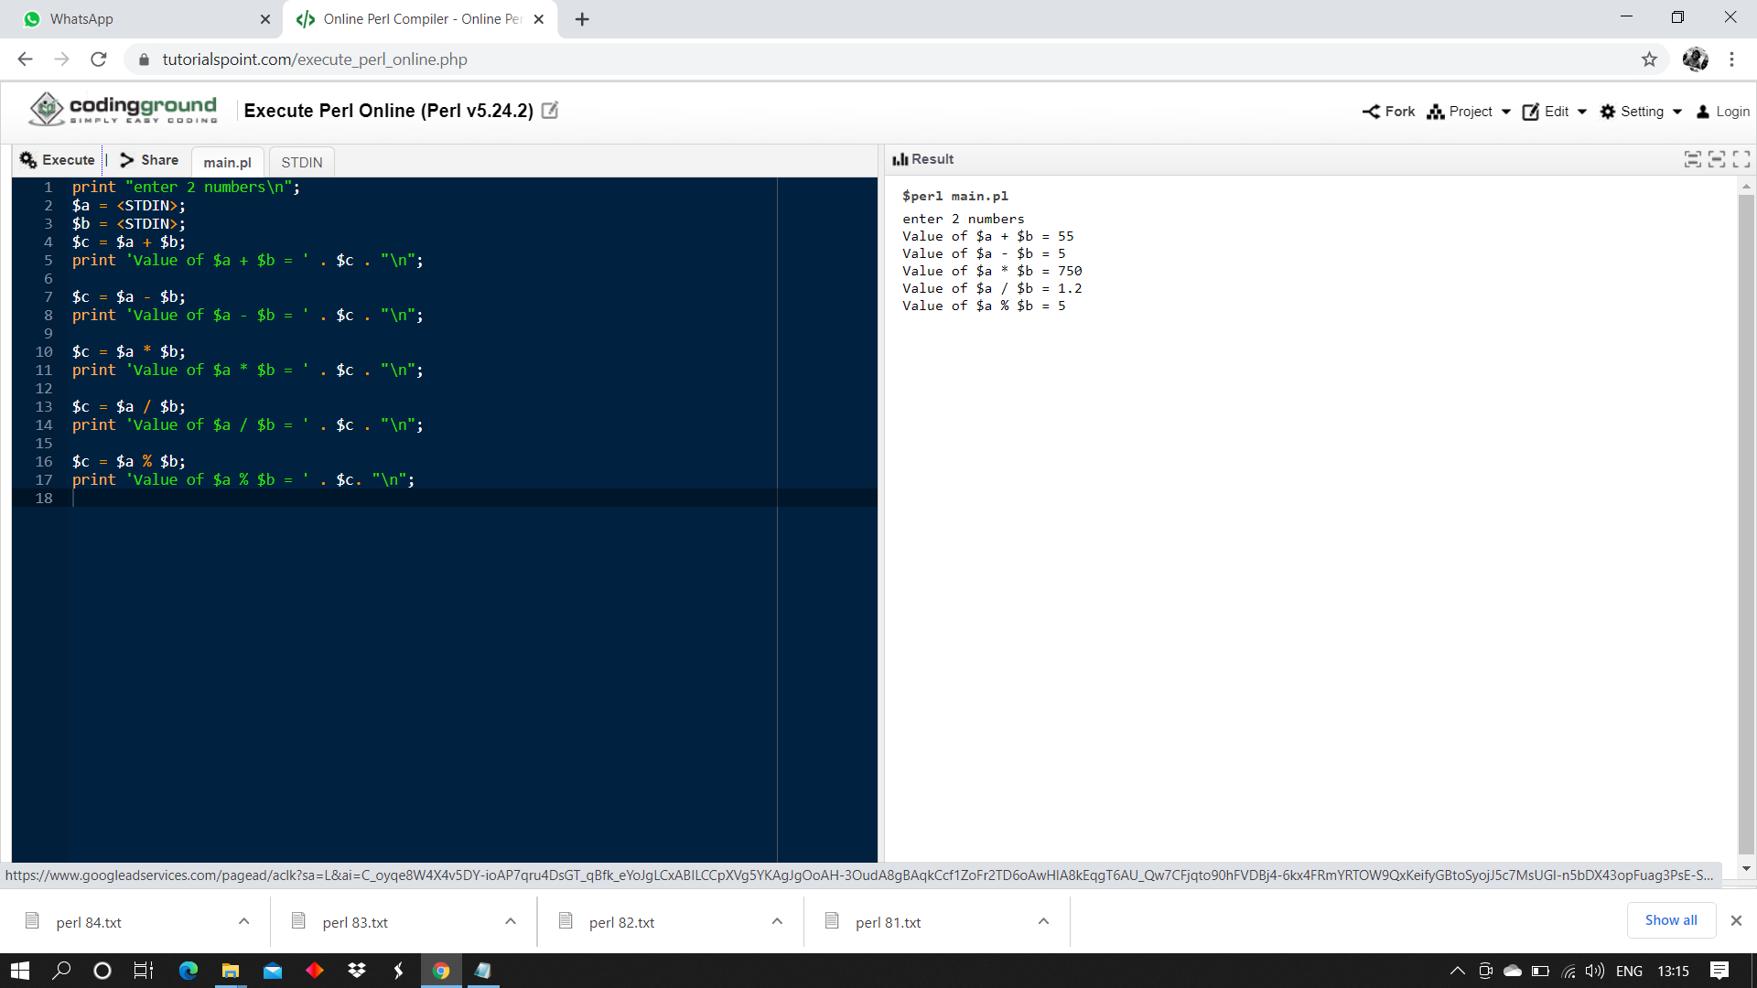

**QUESTION 2: Demonstrate all the escape sequences using print and say statement.**

**PROCEDURE:**

1. Print text on new line
2. Print text with @
3. Print text with $
4. Print text with double quote
5. Print text with qq
6. Print text with q

**Output:**

1. \n newline

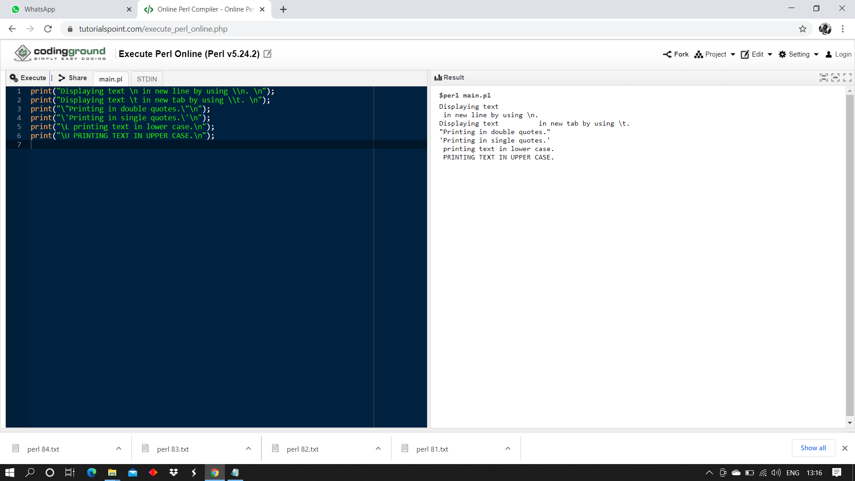

1. Include @
2. $ sign



1. Double quotes “”



1. Double qq

We can replace the double quotes that we use to enclose a string with the double q operator.

The advantage of doing this is that we need not to worry about using escape sequences for double quotes(“) and brackets.



1. Single q operator – q



Single q operator works like single quotes. The special characters present inside it does not interpolate.

**QUESTION 3: Online shopping application**

**PROCEDURE:**

1. Get option from user
2. Get quantity from user
3. Go to respective case and calculate cost (item cost*quantity)
4. Display total cost

**Output:**

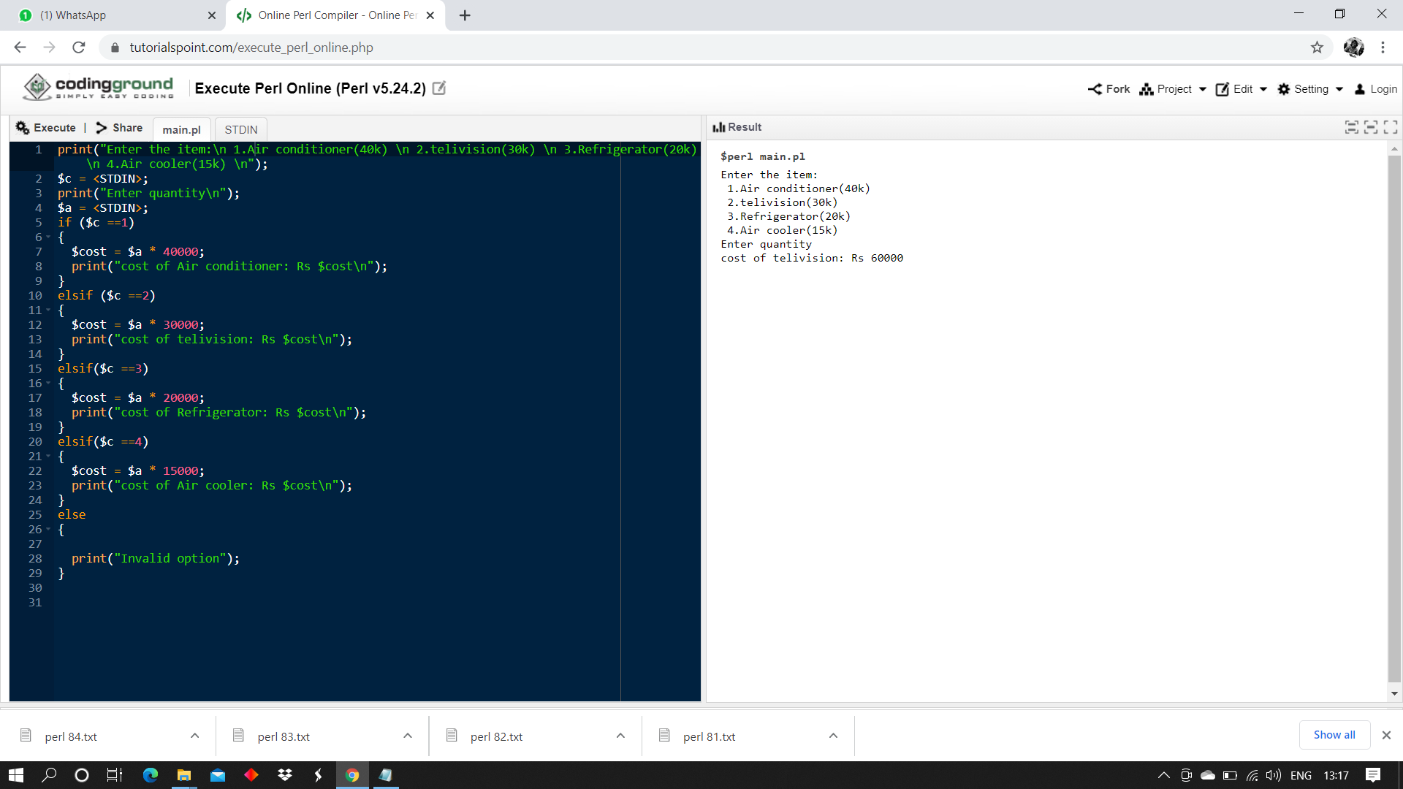

**QUESTION 4: Demonstrate arithmetic assignment operators in perl**

**PROCEDURE:**

1. Get two values from user
2. Use increment operator (+=) and display the value
3. Use decrement operator (-=) and display the value
4. Use multiplication operator (*=) and display the value
5. Use division operator (/=) and display the value
6. Use modulo operator (%=) and display the value
7. Use power operator (**=) and display the value

**Output:**

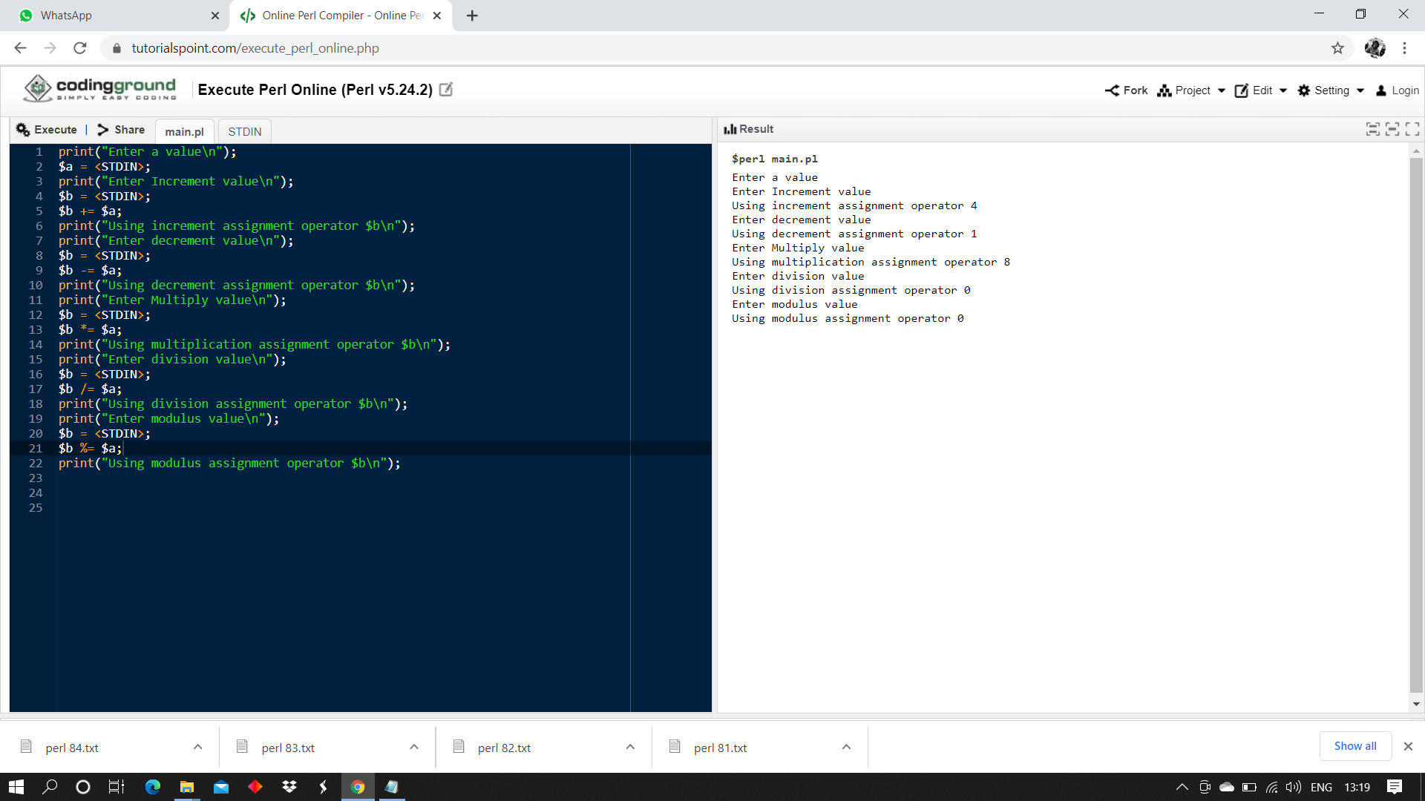

**Video Link:** [**http://www.youtube.com/watch?v=c8r4S2Y8_-4**](http://www.youtube.com/watch?v=c8r4S2Y8_-4)

**RESULT:**

Basic perl programs are successfully executed.

**Ex 9 FUNDAMENTAL OPERATIONS OF PERL**

**Date: 10.11.20**

**Aim:**

To execute basic Perl programs

**Description:**

ARRAYS IN PERL:

An array is a variable that stores an ordered list of scalar values. Array variables are preceded by an "at" (@) sign. To refer to a single element of an array, you will use the dollar sign ($) with the variable name followed by the index of the element in square brackets.

@ages = (25, 30, 40);

@names = ("John Paul", "Lisa", "Kumar");

print "\$ages[0] = $ages[0]\n";

print "\$ages[1] = $ages[1]\n";

print "\$ages[2] = $ages[2]\n";

print "\$names[0] = $names[0]\n";

print "\$names[1] = $names[1]\n";

print "\$names[2] = $names[2]\n";

ARITHEMATIC OPERATIONS OF PERL:

|  |  |
| --- | --- |
| **Sl.No.** | **Operator & Descriptio** |
| 1 | **+ ( Addition )**  **Example** − $a + $b will give 30 |
| 2 | **- (Subtraction)**  **Example** − $a - $b will give -10 |
| 3 | **\* (Multiplication)**  **Example** − $a * $b will give 200 |
| 4 | **/ (Division)**  **Example** − $b / $a will give 2 |
| 5 | **% (Modulus)**  **Example** − $b % $a will give 0 |
| 6 | **\*\* (Exponent)**  **Example** − $a**$b will give 10 to the power 20 |

**QUESTION 1: Demonstrate various operators in perl.**

**PROCEDURE:**

1. Get choice from user for arithmetic, comparison, string, bitwise operation
2. If arithmetic operation then choice operation
3. Perform operation and print the value
4. If comparison operation
5. Enter 2 values
6. Check if values are equal or greater than or less than
7. Print the output
8. If string operation then enter two strings
9. Perform concatenation operation and print the result
10. If bitwise operation then enter two values
11. Perform bitwise &,|, <<, >> and print the value

**Source code:**

# Perl oprators

print("Choose an option: \n 1.Arithmetic operation \n 2.Comparision operation\n 3.String Operation \n 4.Bitwise Operation\n");

$c = <STDIN>;

if ($c == 1)

{

print("ARITHMETIC OPERATIONS\n");

print("Enter two values\n");

$a = <STDIN>;

$b = <STDIN>;

print("Choose an option: \n 1.Addition \n 2.Subtraction\n 3.multiplication \n 4.Division \n 5.Modulus\n");

$op = <STDIN>;

if($op == 1)

{

$tot = $a+$b;

print("Sum of numbers: $tot\n");

}

elsif ($op ==2)

{

$tot = $a-$b;

print("Difference between both values: $tot\n");

}

elsif ($op == 3)

{

$tot = $a*$b;

print("Product of both the numbers: $tot\n");

}

elsif ($op == 4)

{

$tot = $a/$b;

print("Qoutinent of both the numbers: $tot\n");

}

elsif ($op == 5)

{

$tot = $a%$b;

print("Modulus of both the numbers: $tot\n");

}

else

{

print ("Invalid Option\n");

}

}

elsif ($c == 2)

{

print("COMPARISION OPERATION\n");

print("Enter two values\n");

$a = <STDIN>;

$b = <STDIN>;

if($a == $b)

{

print("The values are equal\n");

}

elsif($a >$b)

{

print ("Greater value: $a\n");

print ("Lower values: $b\n");

}

else

{

print("Lower value: $a\n");

print("Greater value: $b\n")

}

if($a != $b)

{

print("Both values are not equal\n");

}

}

elsif ($c == 3)

{

print("STRING OPERATION\n");

print("Enter two strings\n");

$x = <STDIN>;

$y =<STDIN>;

$z = $x.$y;

print("Conactenated String: $z");

}

elsif ($c == 4)

{

print("BITWISE OPERATOR\n");

print("Enter two values\n");

$a = <STDIN>;

$b = <STDIN>;

$and = $a &$b;

print("Performing bitwise AND: $and\n");

$or = $a|$b;

print("Printing bitwise OR: $or");

$left = $a<<2;

print("Performing left shift: $left");

$right = $a>>2;

print("Performing right shift: $right");

}

else

{

print("Invalid Operation");

}

**Output:**

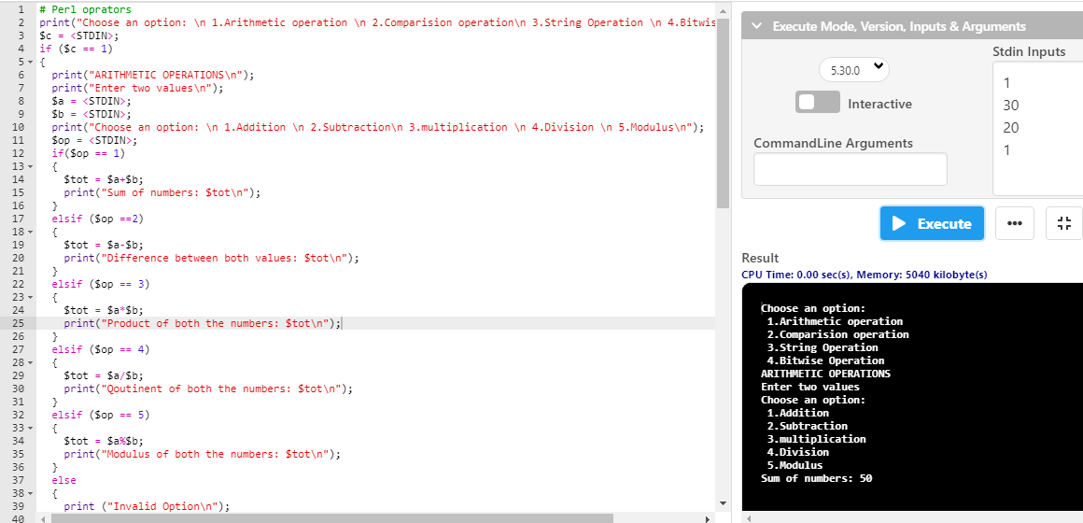

**QUESTION 2: Print 10 inputs received from the user.**

**PROCEDURE:**

1. Create a for loop that executes from 0 to 9
2. Input values into an array
3. Print the array

**Source code :**

print ("Enter 10 values\n");

for ($i =0; $i<10;$i++)

{

$arr[$i]=<STDIN>;

}

print("THE VALUES:\n");

for ($i =0; $i<10;$i++)

{

print $arr[$i];

}

**Output:**

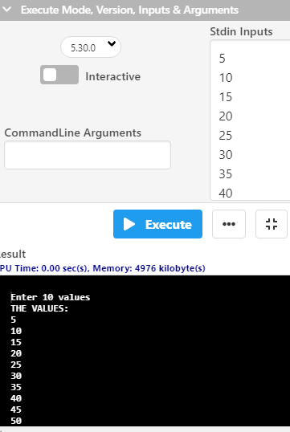

**Video Link:**

<http://www.youtube.com/watch?v=do_sMFmSPsU>

**RESULT:**

Basic perl programs are successfully executed.

**Ex 10 KERNEL INSTALLATION**

**Date: 17.11.20**

**Aim:**

To study and implement the kernel installation.

**Description:**

**Kernel Space:**

Here, the Linux Kernel exists which can be further divided into three levels. At the top is the system call interface, which implements the basic functions such as read and write. Below the system call interface is the kernel code, which can be more accurately defined as the architecture-independent kernel code. This code is common to all of the processor architectures supported by Linux. Below this is the architecture-dependent code, which forms what is more commonly called a BSP (Board Support Package). This code serves as the processor and platform-specific code for the given architecture.

**Commands:**

|  |  |  |  |
| --- | --- | --- | --- |
| Sl. No. | Command Name | Description | options |
| 1. | rpm | It is an open packaging system, which runs on Red Hat Enterprise Linux as well as other Linux and UNIX systems | **-a, --all**  Query all packages  **-f**  Query for packages owning given file |
| 2. | uname | uname displays the information about the system. | **-a**  It prints all the system information in the order  **-s**  It prints the kernel name.  **-n**  It prints the hostname of the network node  **-r**  It prints the kernel release date  **-v**  It prints the version of the current kernel |
| 3. | tar | tar’ stands for tape archive, is used to create Archive and extract the Archive files | **-c**  Creates Archive  **-x**  Extract the archive  **-f**  Creates archive with given filename  **-t**  Displays or lists files in archive file  **-u**  Archives and adds to an existing archive file  **-A**  Concatenates the archive files  **-z**  zip, tells tar command that create tar file using gzip  **-W**  Verify a archive file  **-r**  update or add file or directory in already existed .tar file |
| 4. | ln | A symbolic link, also known as a symlink or soft link, is a special type of file that points to another file or directory. | * Hard links * Soft links |
| 5. | make | utility for building and maintaining groups of programs. | **-b,-m**  prints online help and exit.  **-B**  Unconditionally make all targets  **-d**  Print debugging information in addition to normal processing  **-e**  Give variables taken from the environment precedence over variables from makefiles  **-k**  Continue as much as possible after an error |

**Exercise:**

**Steps involved in the configuration process:**

**Step 1 :**

Move the module from downloads to /usr/src and uzip the file.

**Step 2 :**

Make a systemlink to the existing kernel and clean the existing kernel.

**Step 3 :**

Building kernel and its modules.

**Step 4 :**

Check the current kernel version and name of the kernel.

**Output:**

Download the Kernel

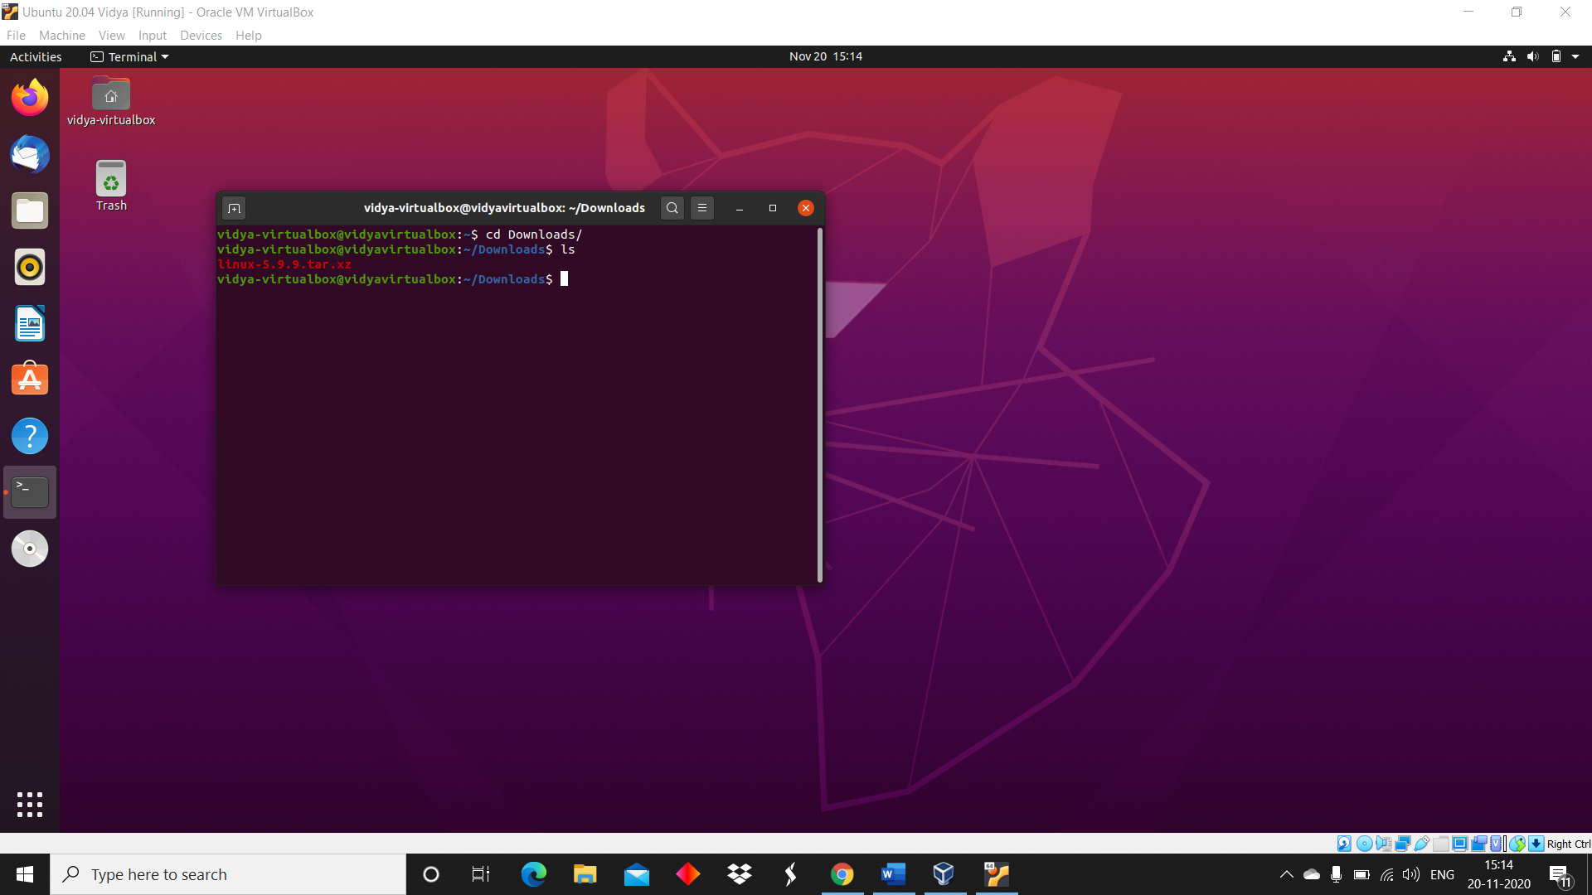

Moving the kernel to /usr/src

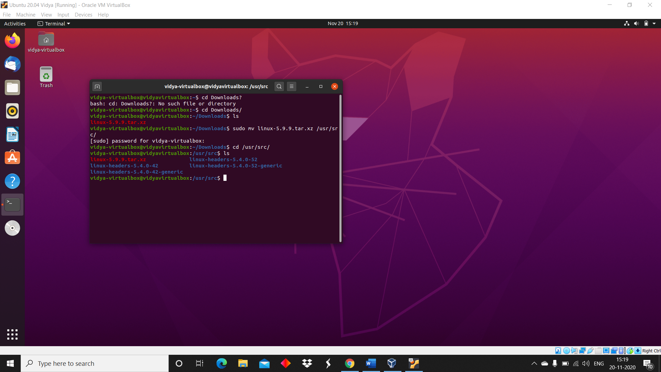

Extract the kernel using tar

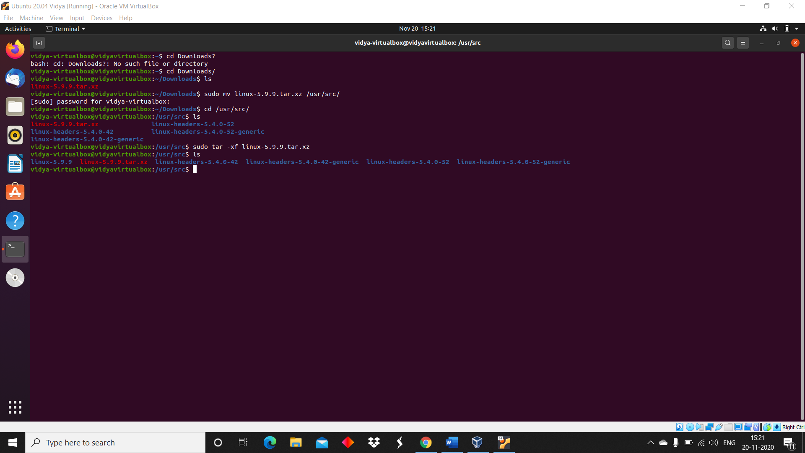

System link to existing kernel

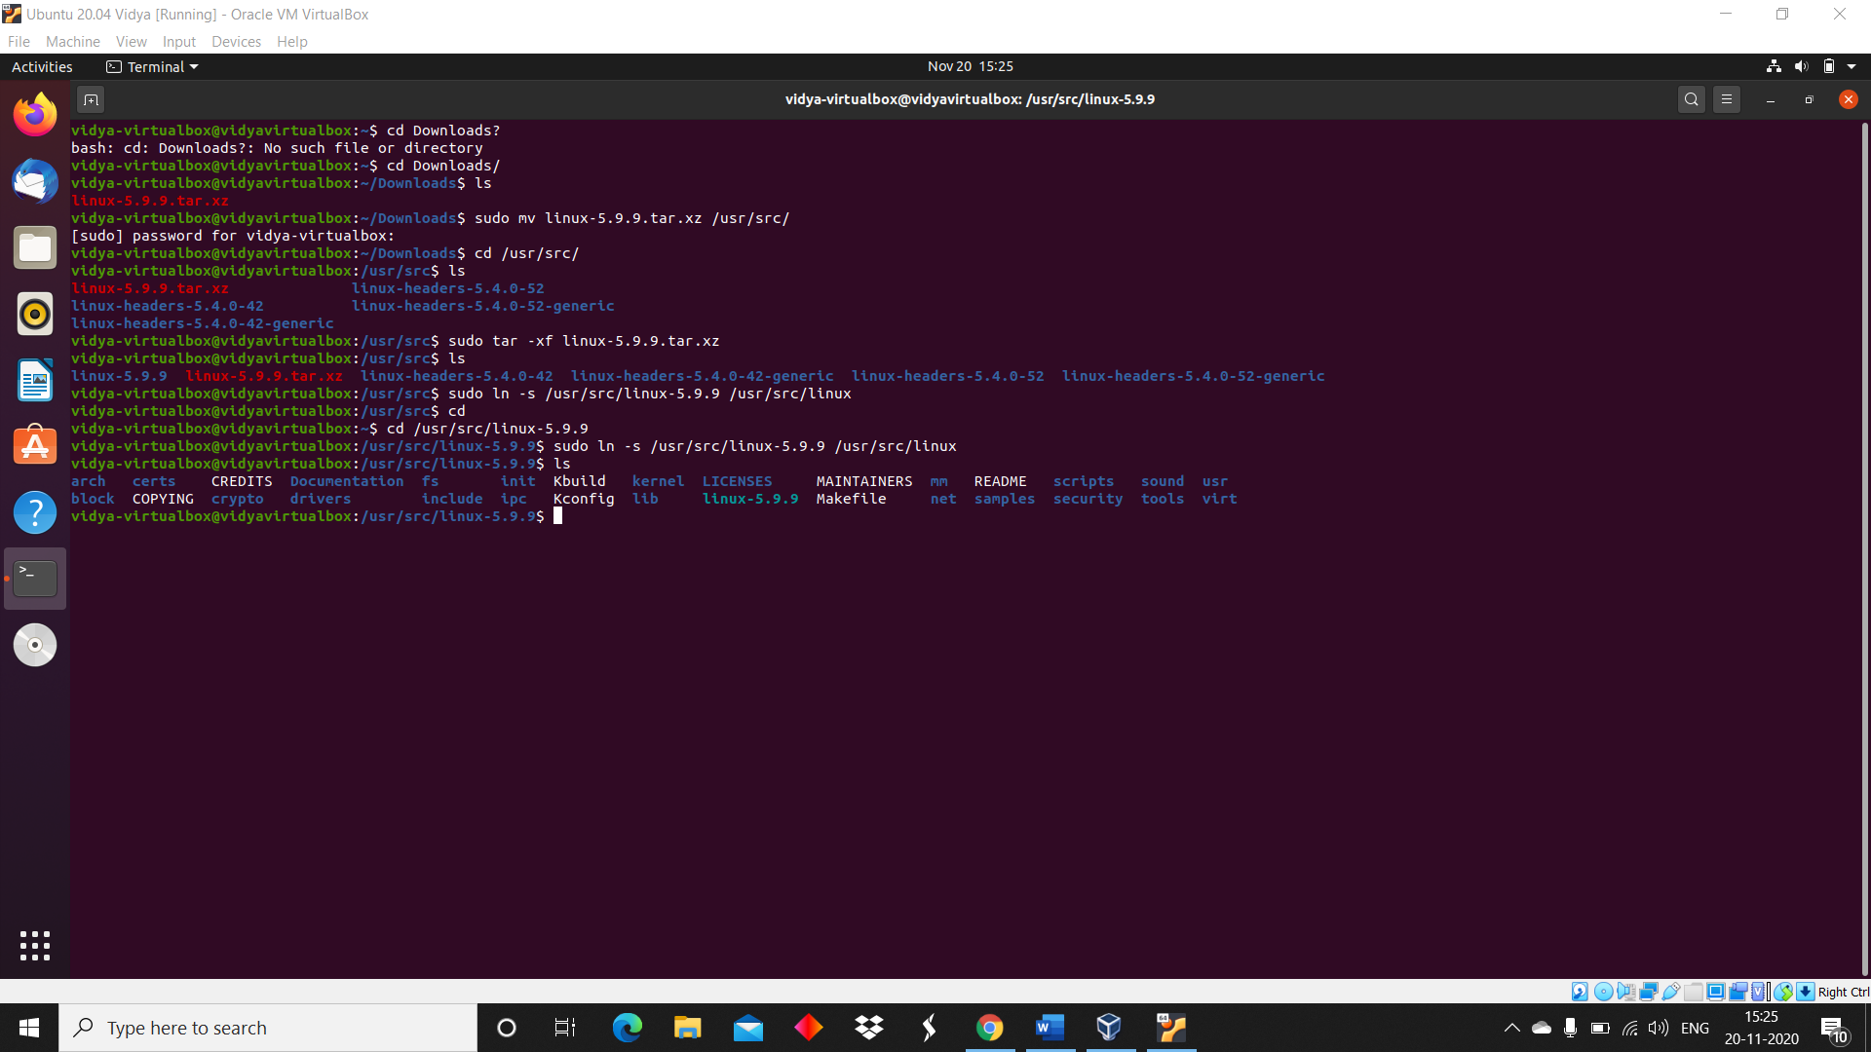

Making target files

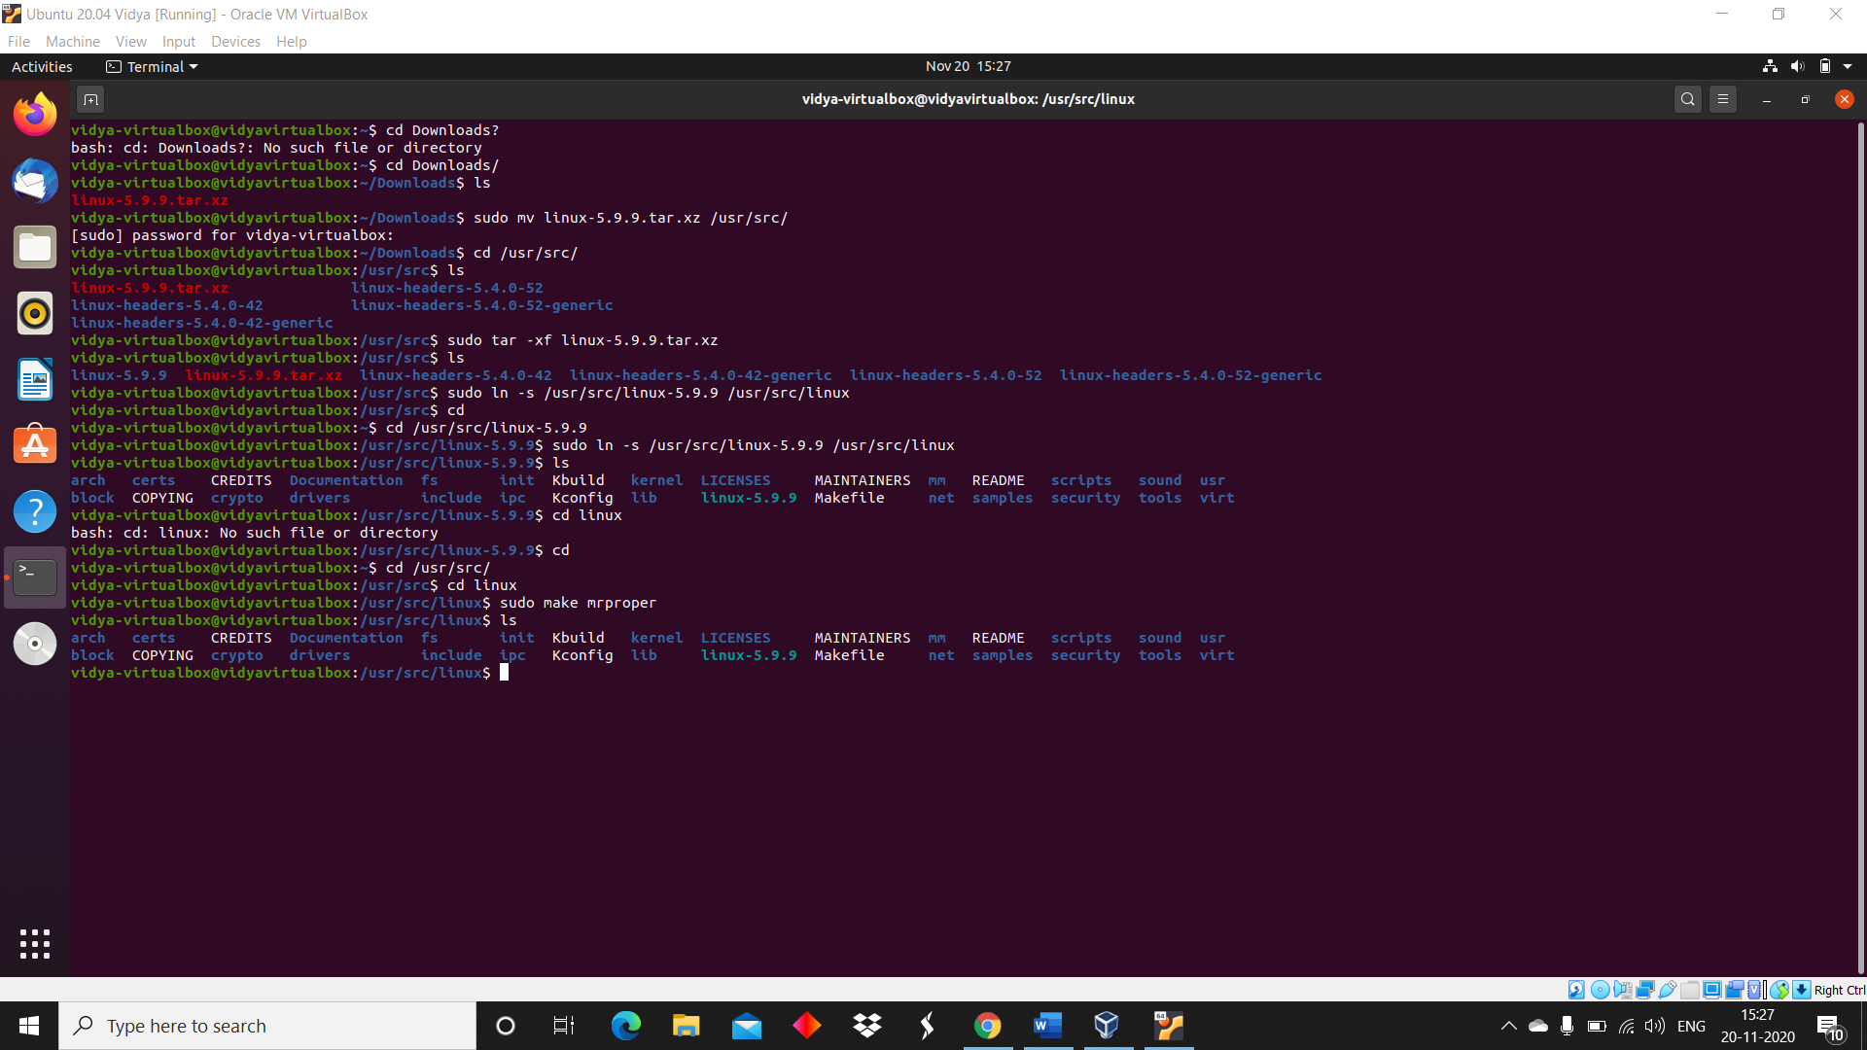

**Results:**

The study and implement the kernel installation is studied and executed.

**Video Link:** <http://www.youtube.com/watch?v=DZjTMD_pd4U>